COMPUTER SCIENCE

ASSIGNMENT

**Name :**

**Class**

**Sec-**

**Board Roll Number**

**INDEX**

|  |  |  |
| --- | --- | --- |
| **S No.** | **DESCRIPTION** | **SIGNATURE** |
|  | **REVIEW OF CLASS XI** |  |
|  | **SEARCHING**   1. **Linear Search** 2. **Binary Search** |  |
|  | **SORTING**   1. **Bubble Sort** 2. **Insertion sort** 3. **Selection sort** |  |
|  | **Function (Assignment 1)** |  |
|  | **Recursion (Assignment 2)** |  |
|  | **File Handling (Assignment 3 and 4 )**   1. **Text File** 2. **Binary File** 3. **Csv File** |  |
|  | **STACKS (Assignment 7)**  **Complete Stack Program demonstrating (Push (), POP () and display ())** |  |
|  | **QUEUES (Assignment 8)**  **Complete Stack Program demonstrating (insert (), remove () and display())** |  |
|  | **MYSQL (Assignment 5 and 6)**   1. **Assignment 1** 2. **Assignment 2** |  |

**REVIEW OF CLASS XI**

Lab assignment 1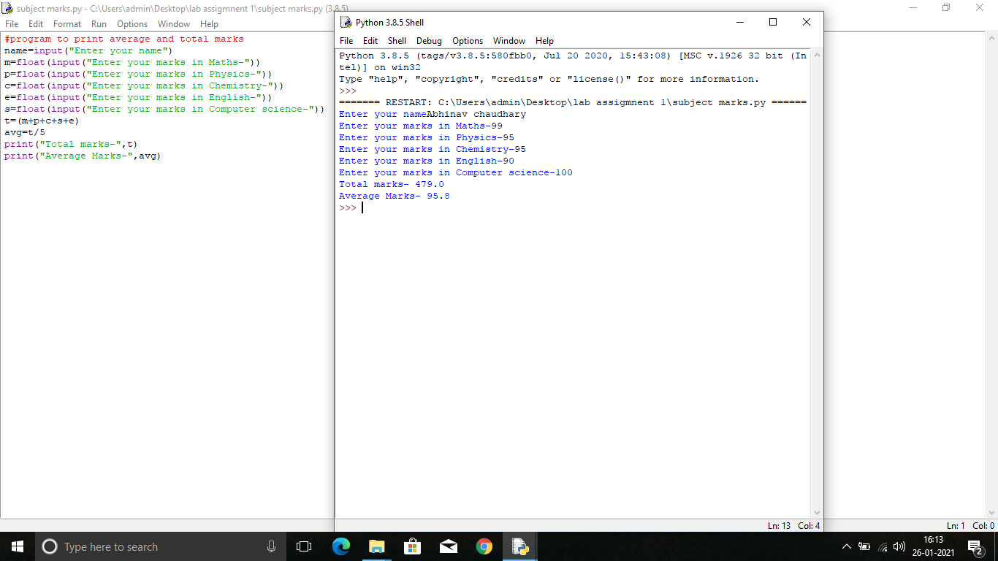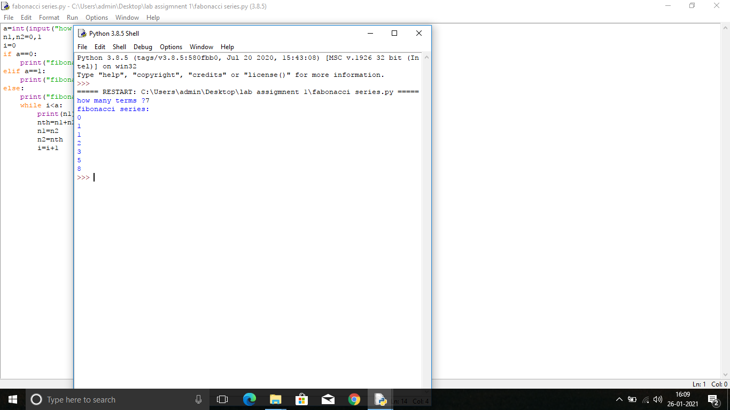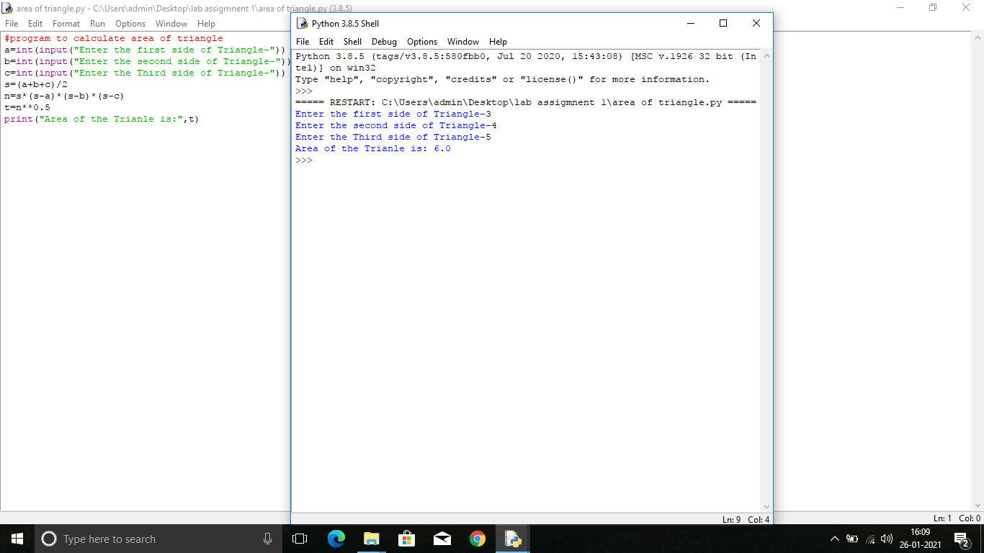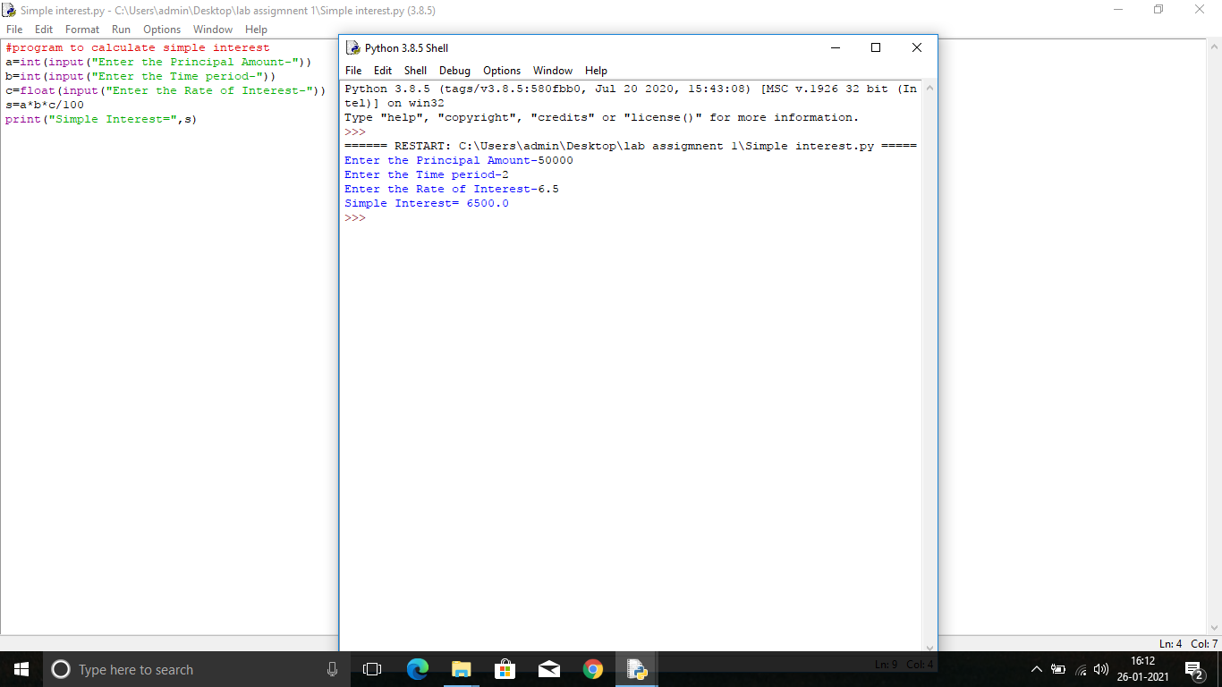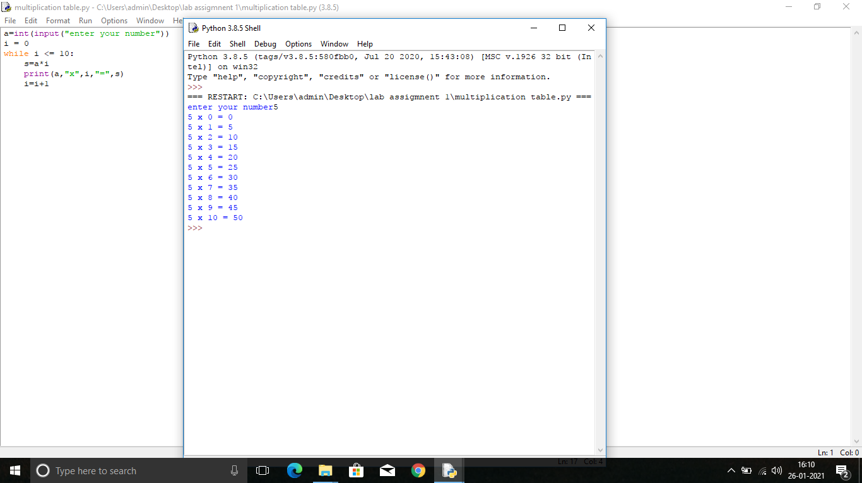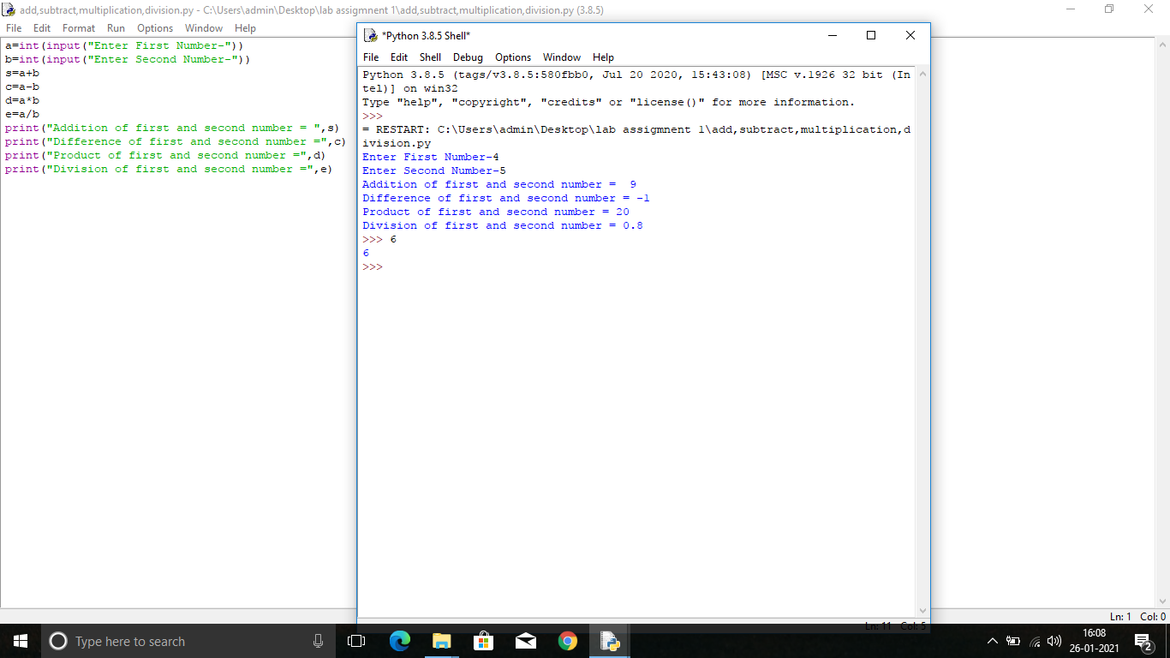 1

Lab assignment 2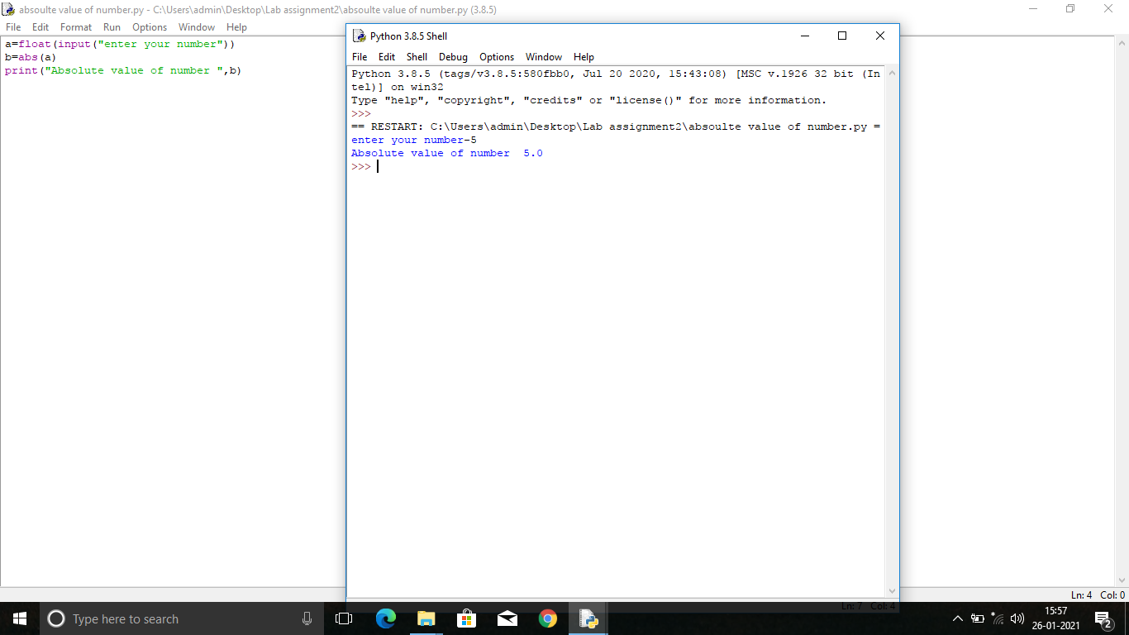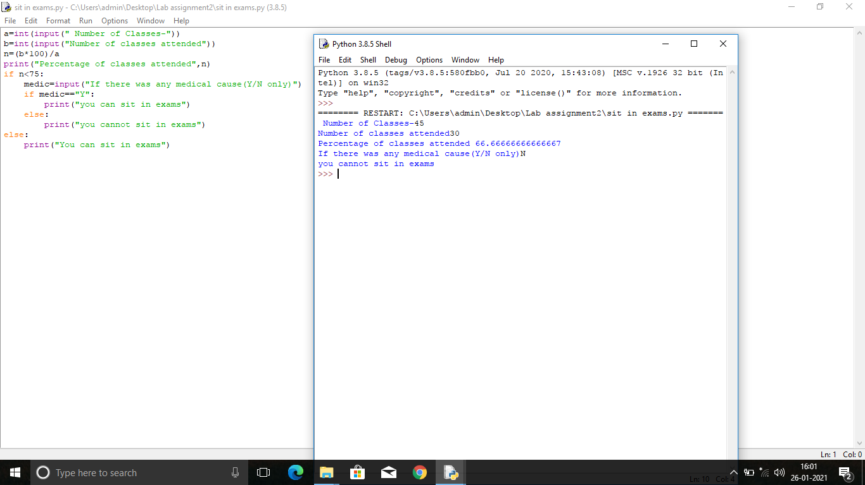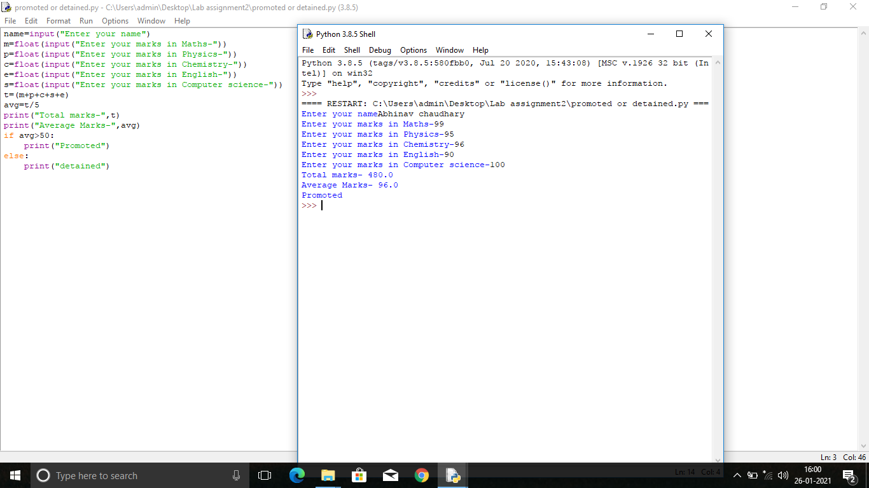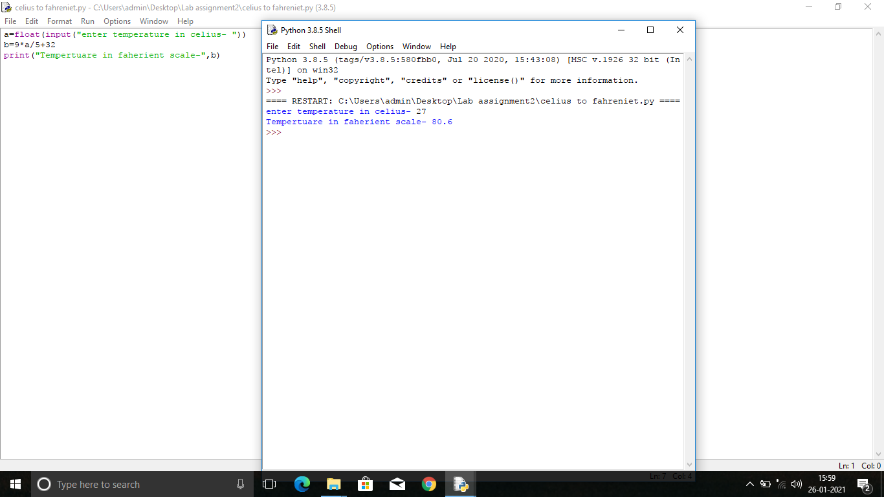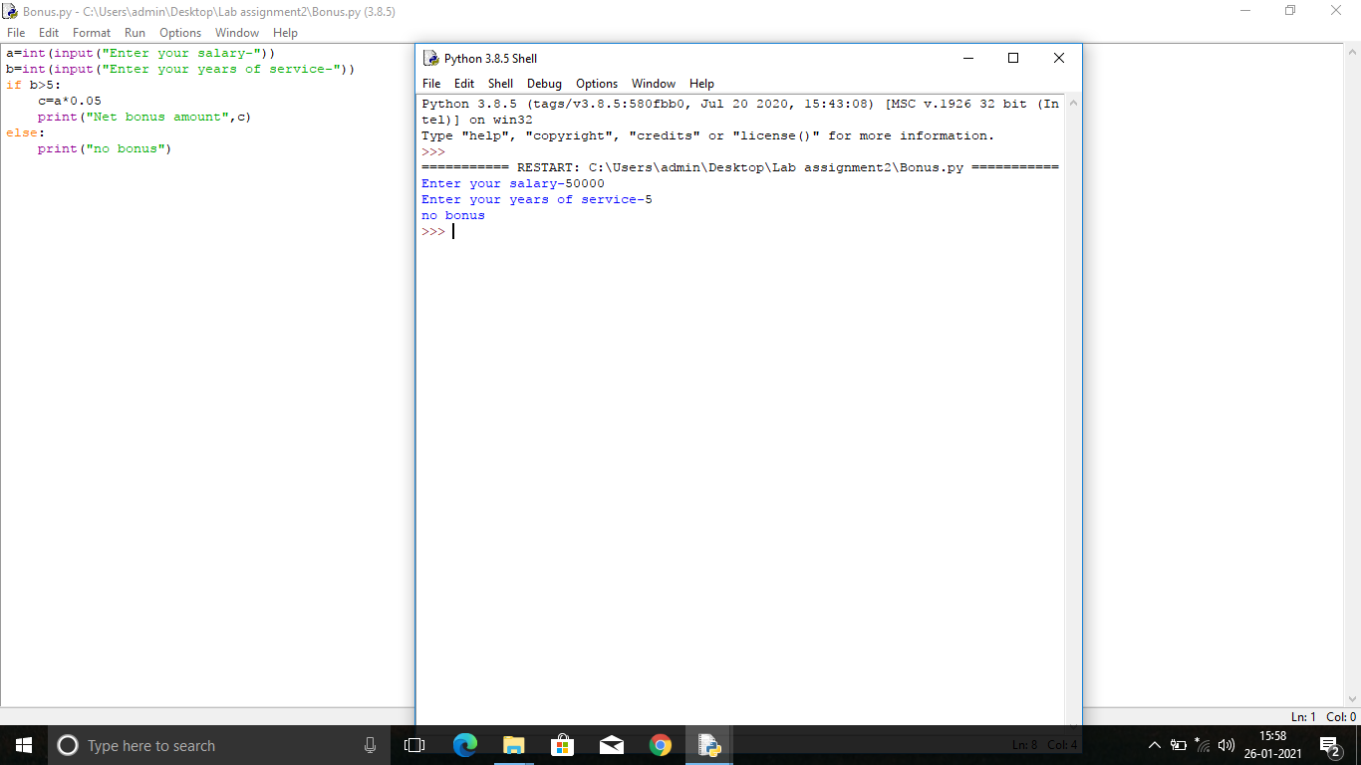

#cube from 1-8

i=1

while i<9:

print(i*i*i)

i=i+1

#prime check

num = int(input("Enter a number: "))

if num > 1:

for i in range(2,num):

if (num % i) == 0:

print(num,"is not a prime number")

break

else:

print(num,"is a prime number")

else:

print(num,"is not a prime number")

#factorial

num = int(input("Enter a number: "))

factorial = 1

if num < 0:

print("Sorry, factorial does not exist for negative numbers")

elif num == 0:

print("The factorial of 0 is 1")

else:

for i in range(1,num + 1):

factorial = factorial*i

print("The factorial of",num,"is",factorial)

#prime from 1-100

for i in range(1,101):

count=0

for j in range(1,i+1):

if (i%j==0):

count=count+1

if count==2:

print(i)

#palindrome check

n=int(input("Enter number:"))

temp=n

rev=0

while(n>0):

dig=n%10

rev=rev*10+dig

n=n//10

if(temp==rev):

print("The number is a palindrome!")

else:

print("The number isn't a palindrome!")

Armstrong check

num = int(input("Enter a number: "))

sum = 0

temp = num

while temp > 0:

digit = temp % 10

sum += digit ** 3

temp //= 10

if num == sum:

print(num,"is an Armstrong number")

else:

print(num,"is not an Armstrong number")

**ASSIGNMENT 4 Series and Patterns**

**(LOOPS)**

**TO BE DONE IN THE ASSINMENT FILE**

1. WAP to display finonacci series upto n terms

e. g

0,1,1,2,3,5…..n

1. WAP to display the following series

1,8,27,64……………..n

1. WAP to find the sum of following series and display.

1+ ½+ 1/3 + ¼ + 1/5 + 1/6…..1/n

Write a program to compute the cosine of x. The user should supply x and a positive integer n. We compute the cosine of x using the series and the computation should use all terms in the series up through the term involving xn

cos x = 1 - x2/2! + x4/4! - x6/6! .....

1. Write a program to print following:

|  |  |  |  |  |  |
| --- | --- | --- | --- | --- | --- |
|  | | | | | |
| **i)** | ********** ********** ********** ********** | **ii)** | * ** *** **** ***** | **iii)** | *       **     ***   **** ***** |
| **iv)** | *      ***   *****  *******  ********* | **v)** | **1** **222** **33333** **4444444** **555555555** |  |  |

Vi A

AB

ABC

ABCD

ABCDE

………..N

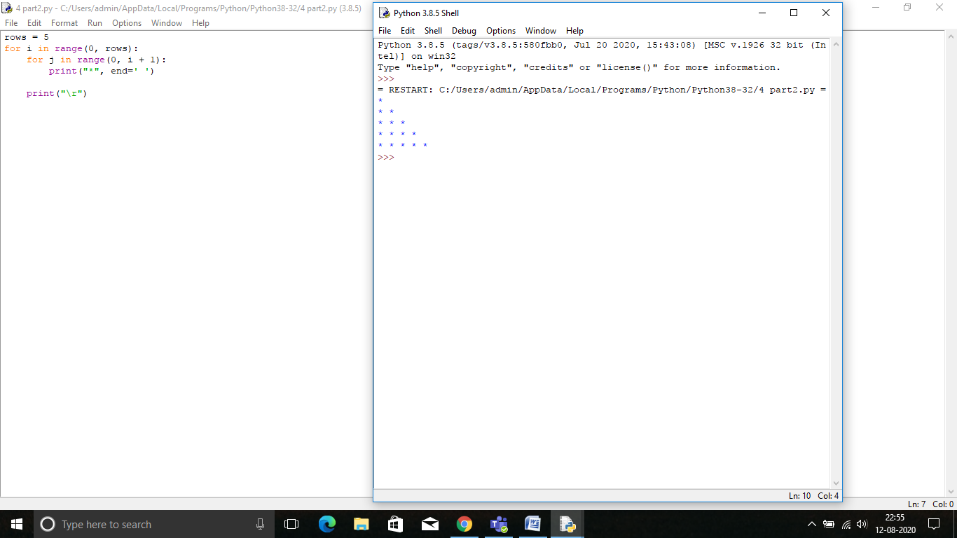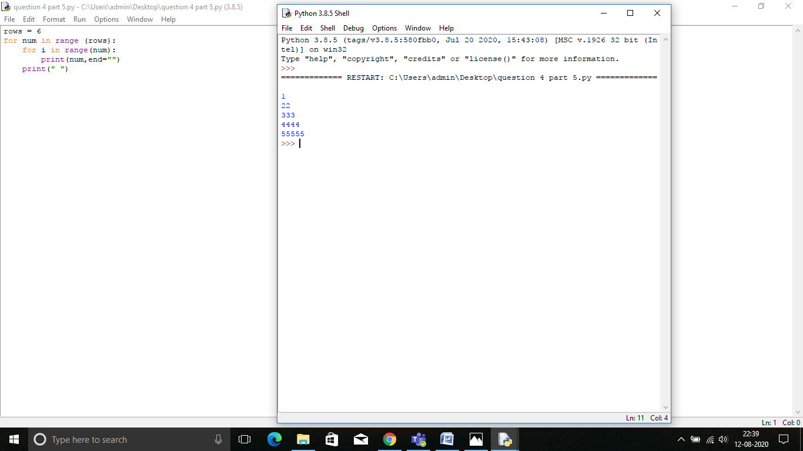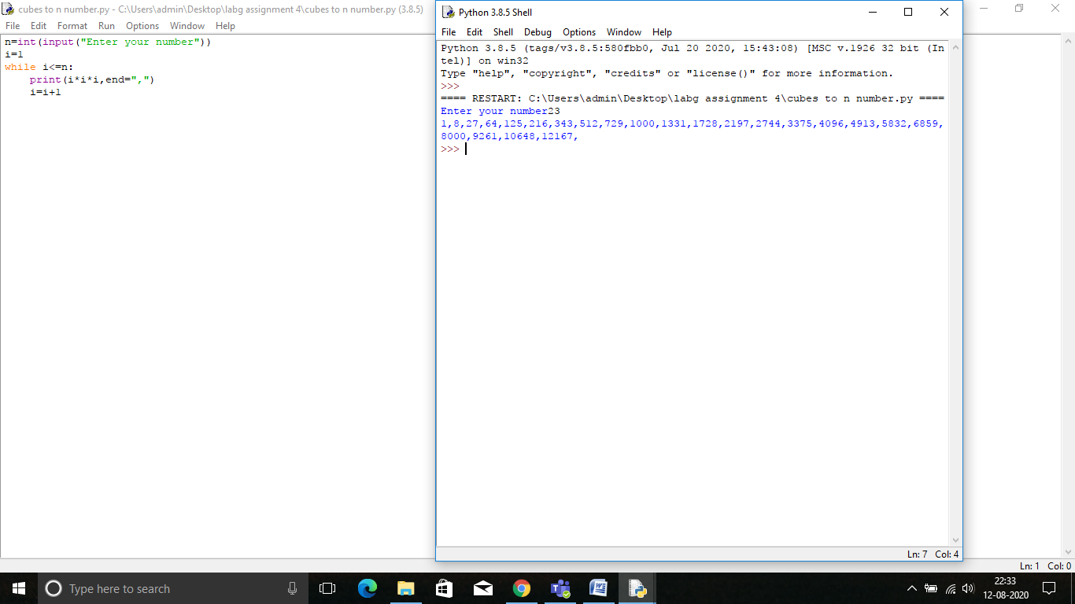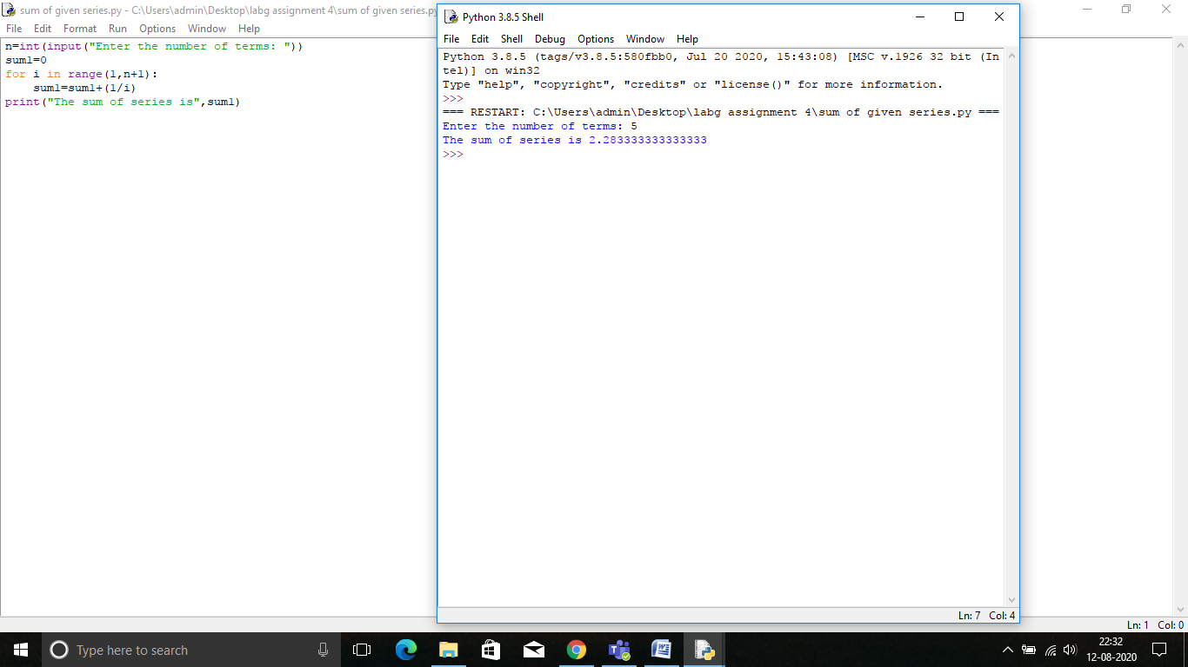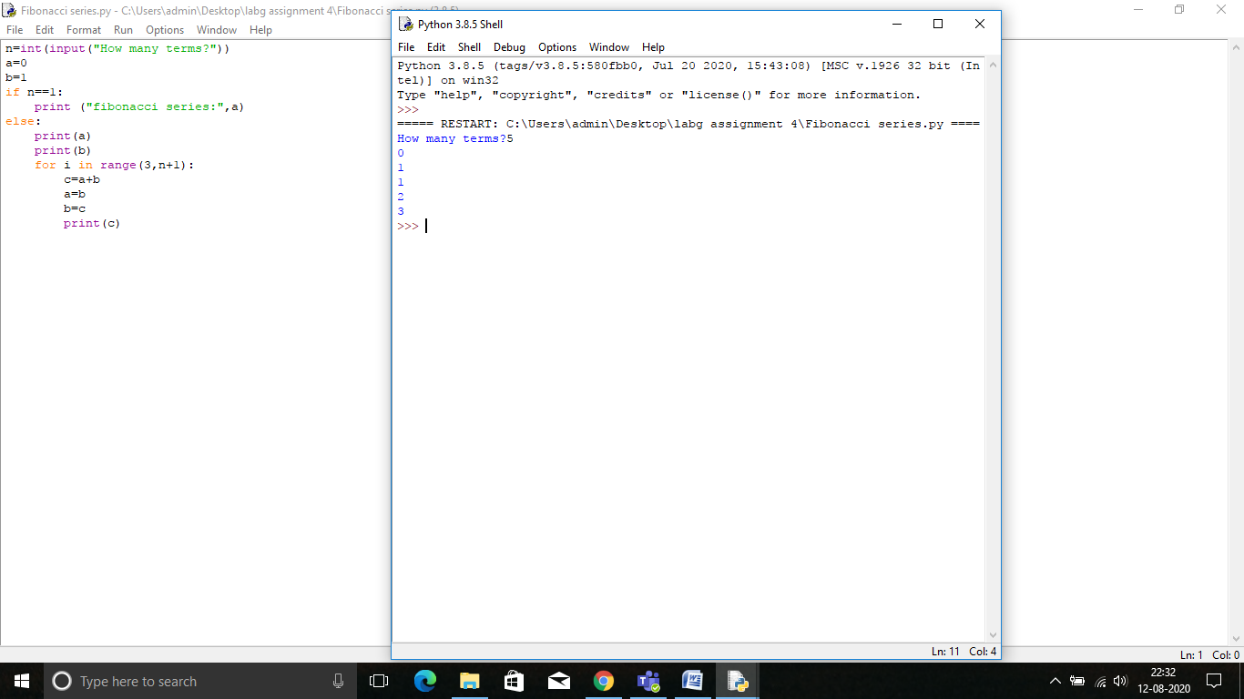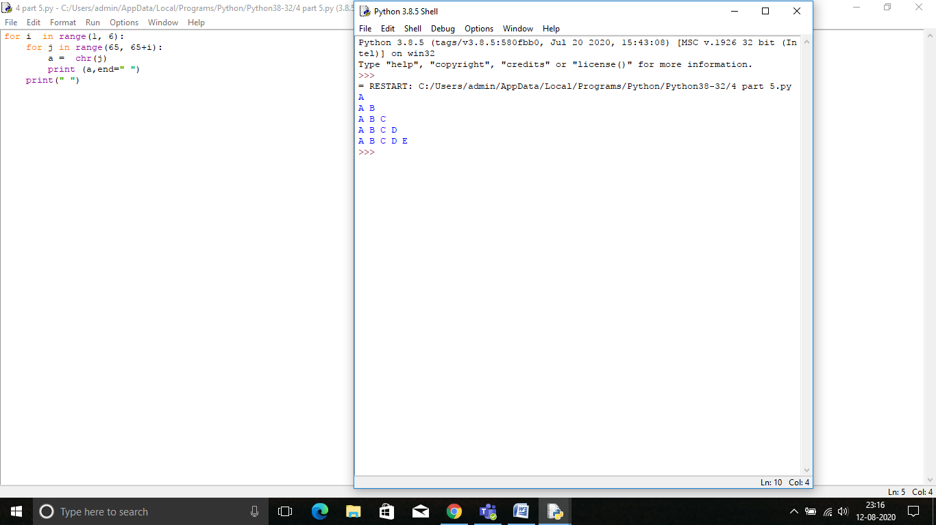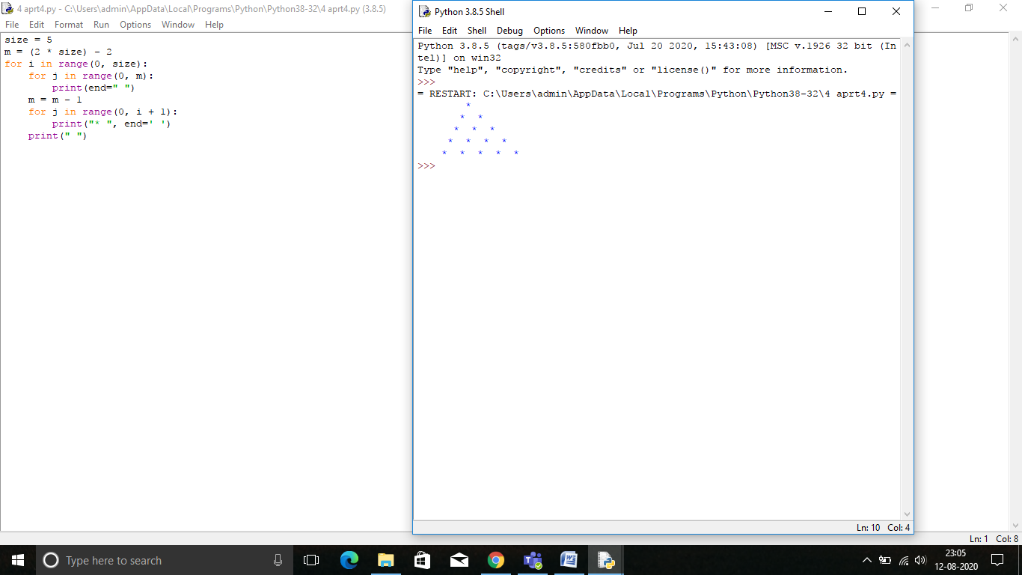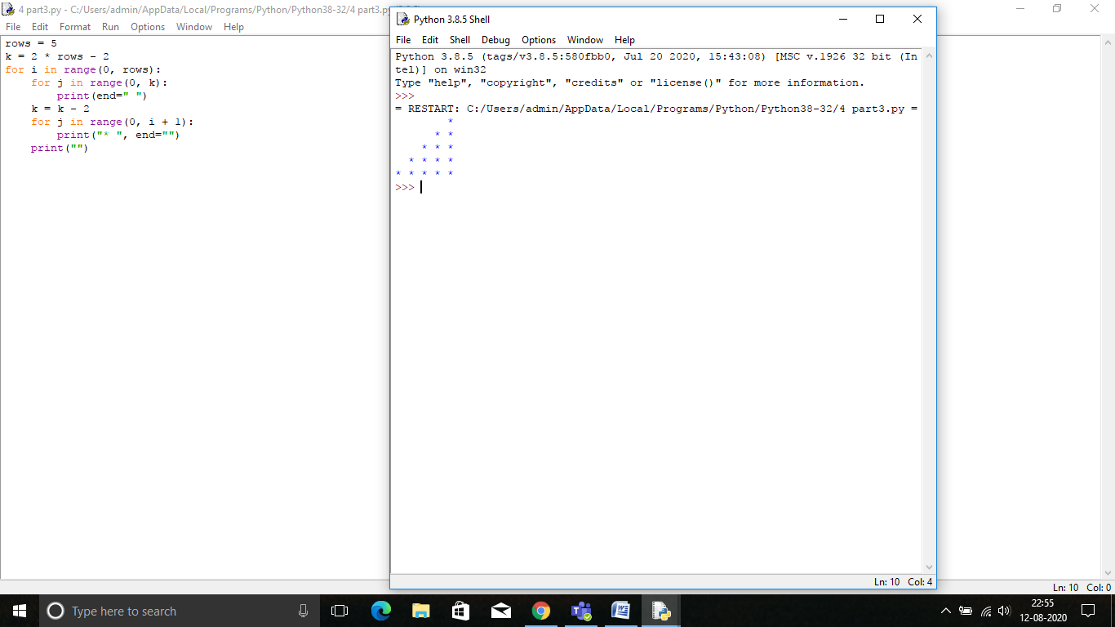

**LAB ASSIGNMENT NUMBER 5 (Strings)**

1. Write a program that takes your full name as input and displays the abbreviations of the first and middle names except the last name which is displayed as it is. For example, if your name is Suman Kumari Garg, then the output should be S.K. Garg.
2. Write a Python program to get a string made of the first 2 and the last 2 chars from a given a string. If the string length is less than 2, return instead of the empty string. Go to the editor Sample String : 'w3resource' Expected Result : 'w3ce' Sample String : 'w3' Expected Result : 'w3w3' Sample String : ' w' Expected Result : Empty String
3. Write a Python program to get a string from a given string where all occurrences of its first char have been changed to '$', except the first char itself.
4. Write a Python program to add 'ing' at the end of a given string (length should be at least 3). If the given string already ends with 'ing' then add 'ly' instead. If the string length of the given string is less than 3, leave it unchanged.
5. Write a Python program to find the first appearance of the substring 'not' and 'poor' from a given string, if 'not' follows the 'poor', replace the whole 'not'...'poor' substring with 'good'. Return the resulting string. Go to the editor Sample String : 'The lyrics is not that poor!' 'The lyrics is poor!' Expected Result : 'The lyrics is good!' 'The lyrics is poor!'
6. Write a program to find the number of vowels, consonents, digits and white space characters in a string.
7. Check the occurrence of the letter 'e' and the word 'is' in the sentence "This is umbrella".

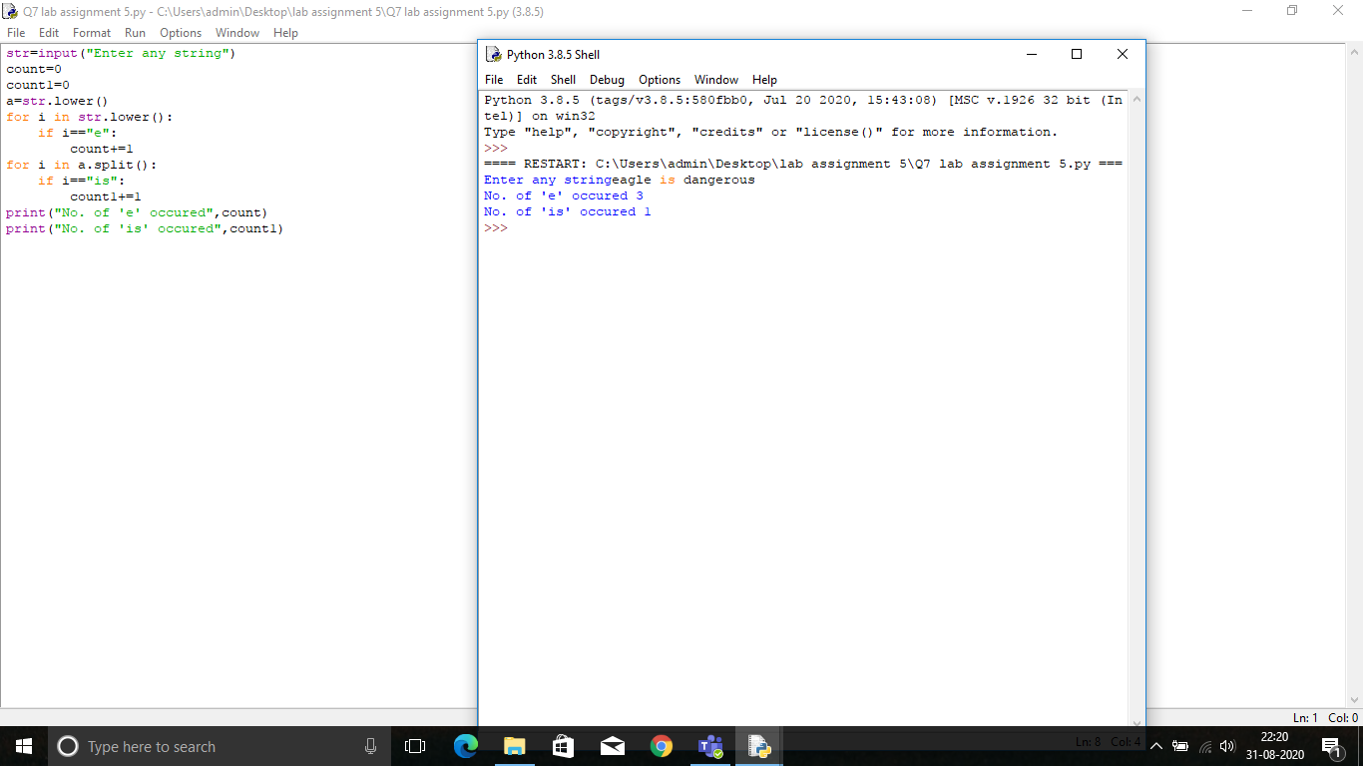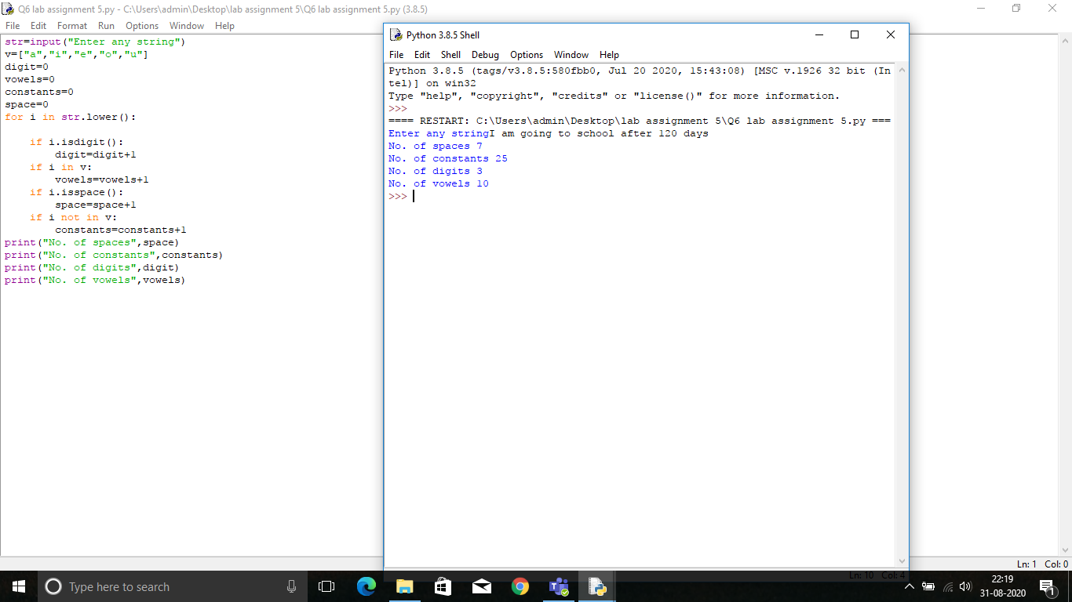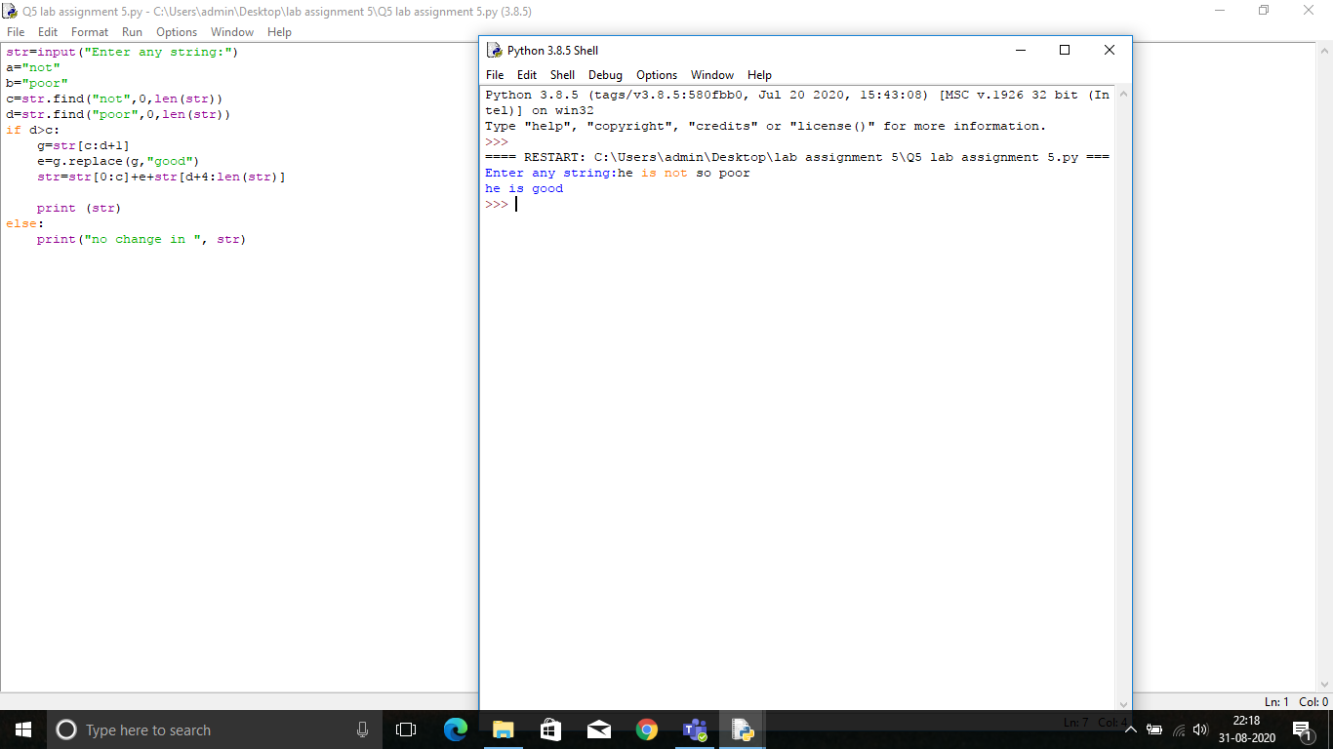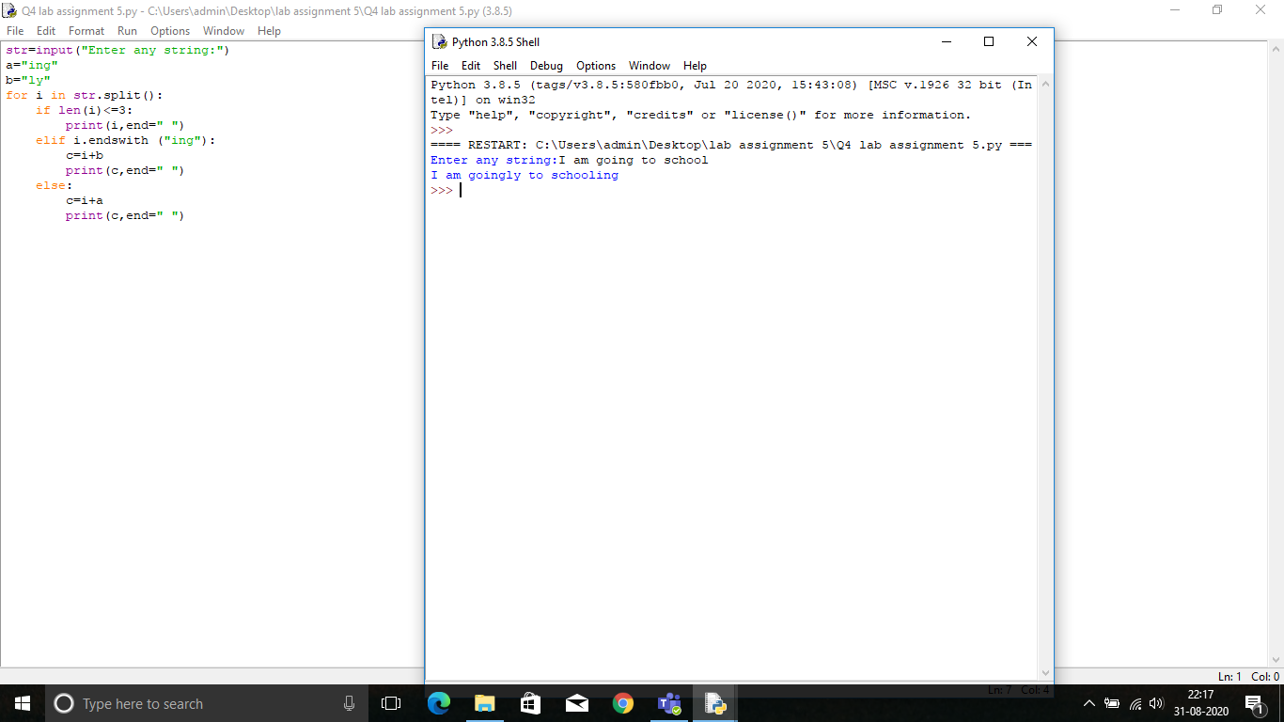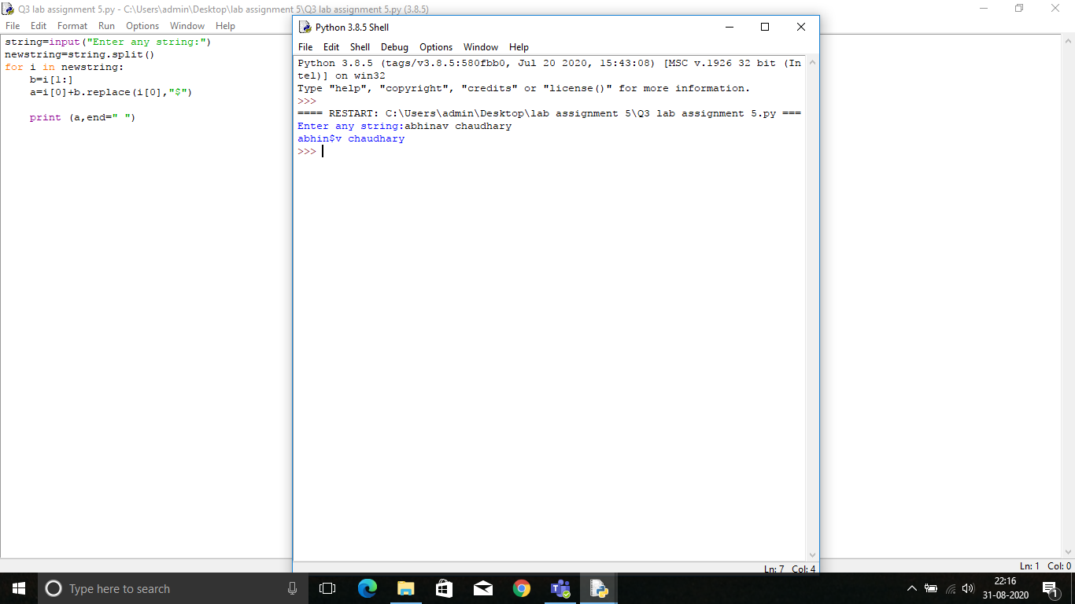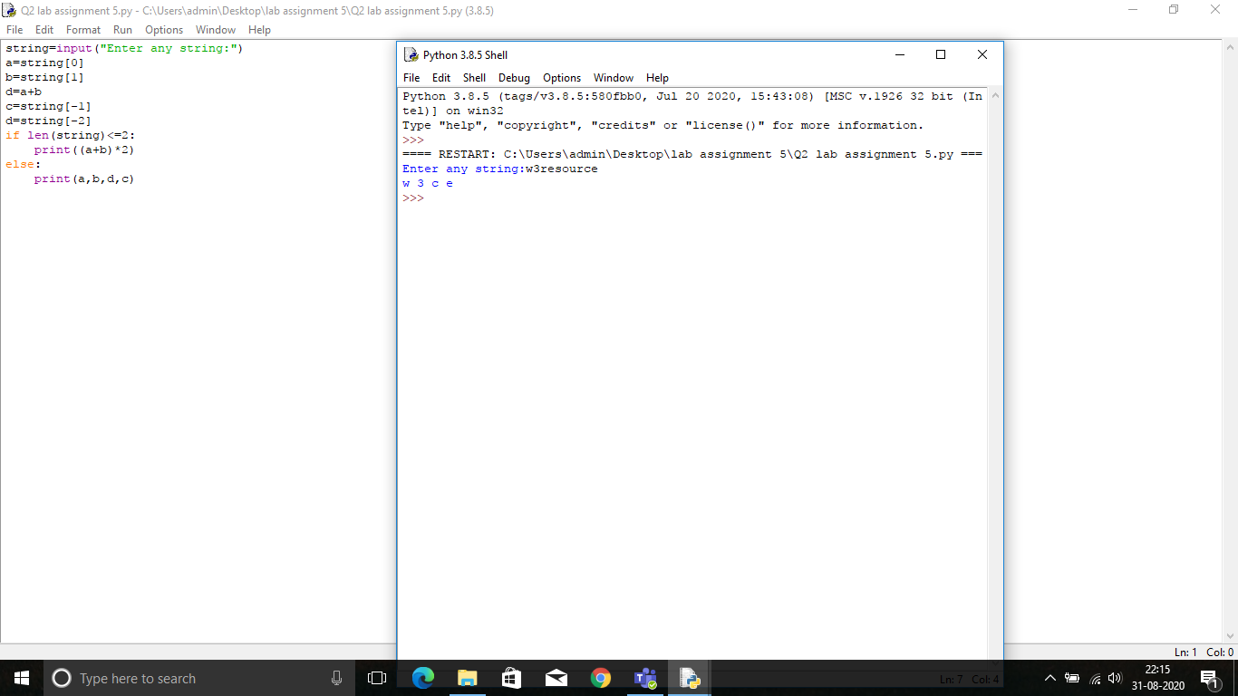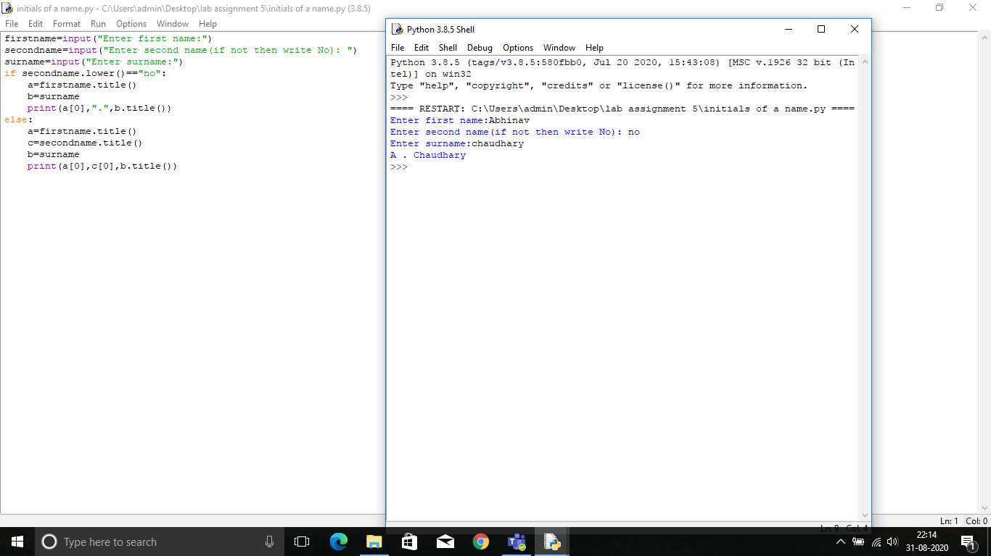

ASSIGNMENT 6 (LISTS)

1. Write a Python program to find sum all the items in a list and prints the result.

2. Write a Python program to get the largest number from a list and print it

3. Write a Python program to get the smallest number from a list

4. Write aprogram in Python to count the frequency of elements in a list.

5. Write a program to input a two digit number and display it in words. For example, if the input is 58, then the output should be Fifty Eight. If the number is not in the range 10 to 99, the program should give an error message.

6. To input a list, named Pay, from the user and modify each element of Pay, as per the following rules:

Existing value of Pay Pay to be changed to

If less than 100000 Add 25% in the existing value

If >= 100000 and <200000 Add 20% in the existing value

If >= 200000 Add 15% in the existing value

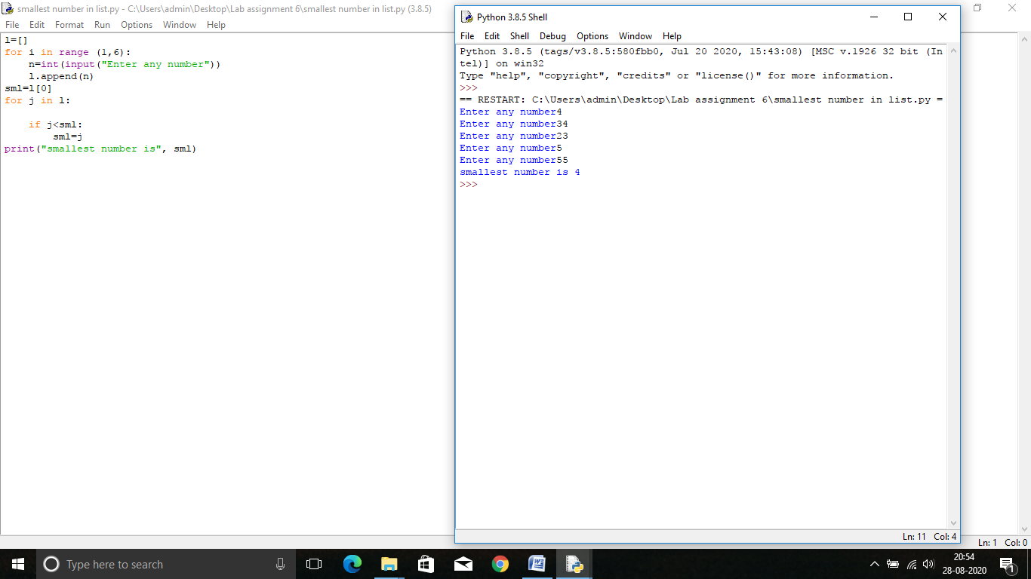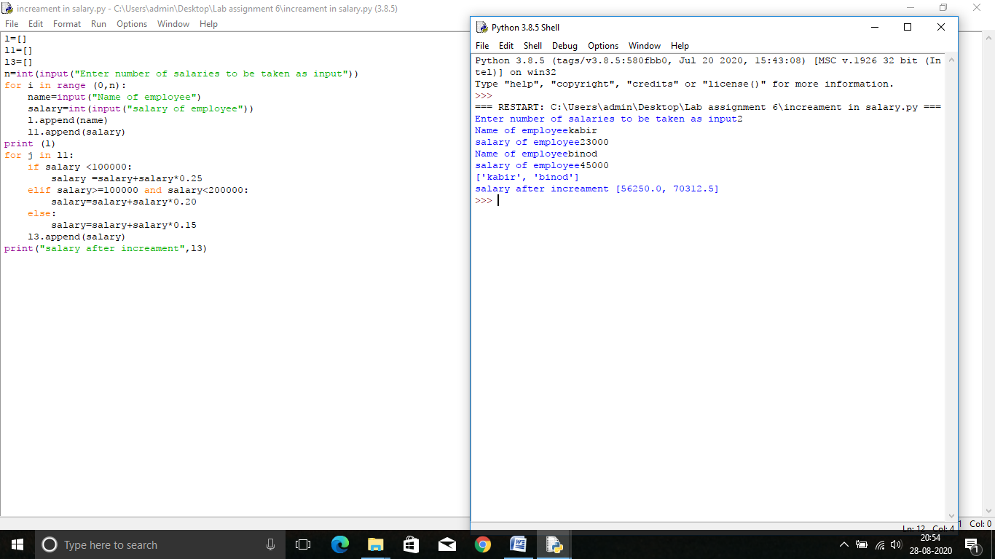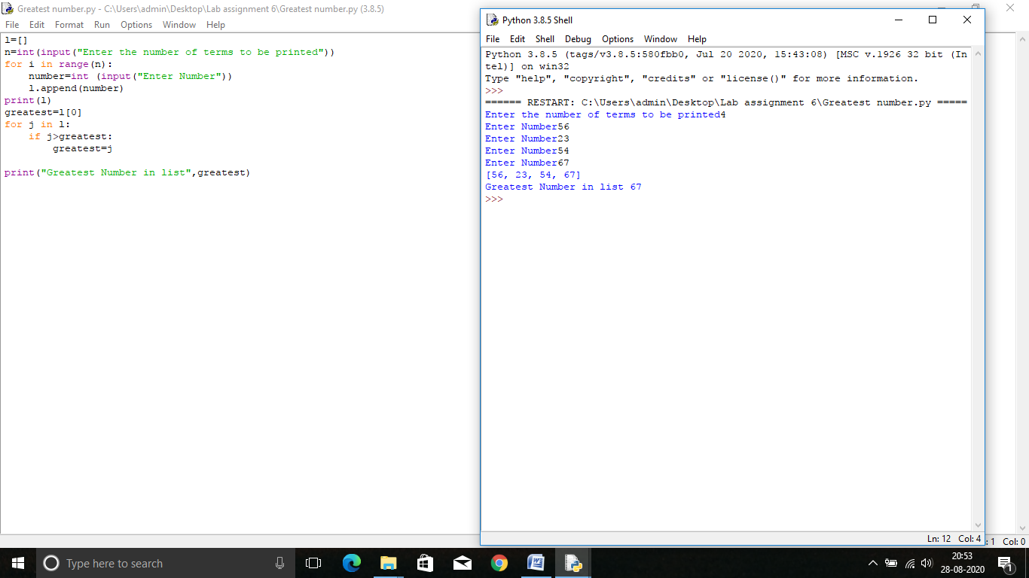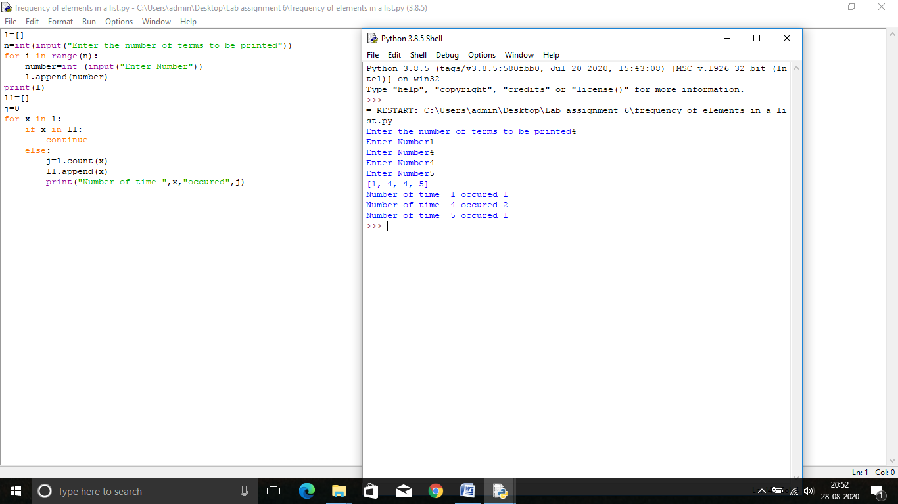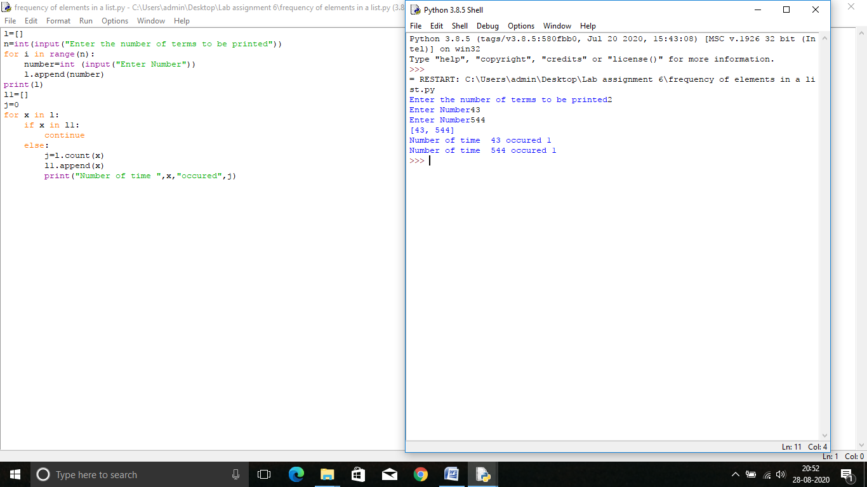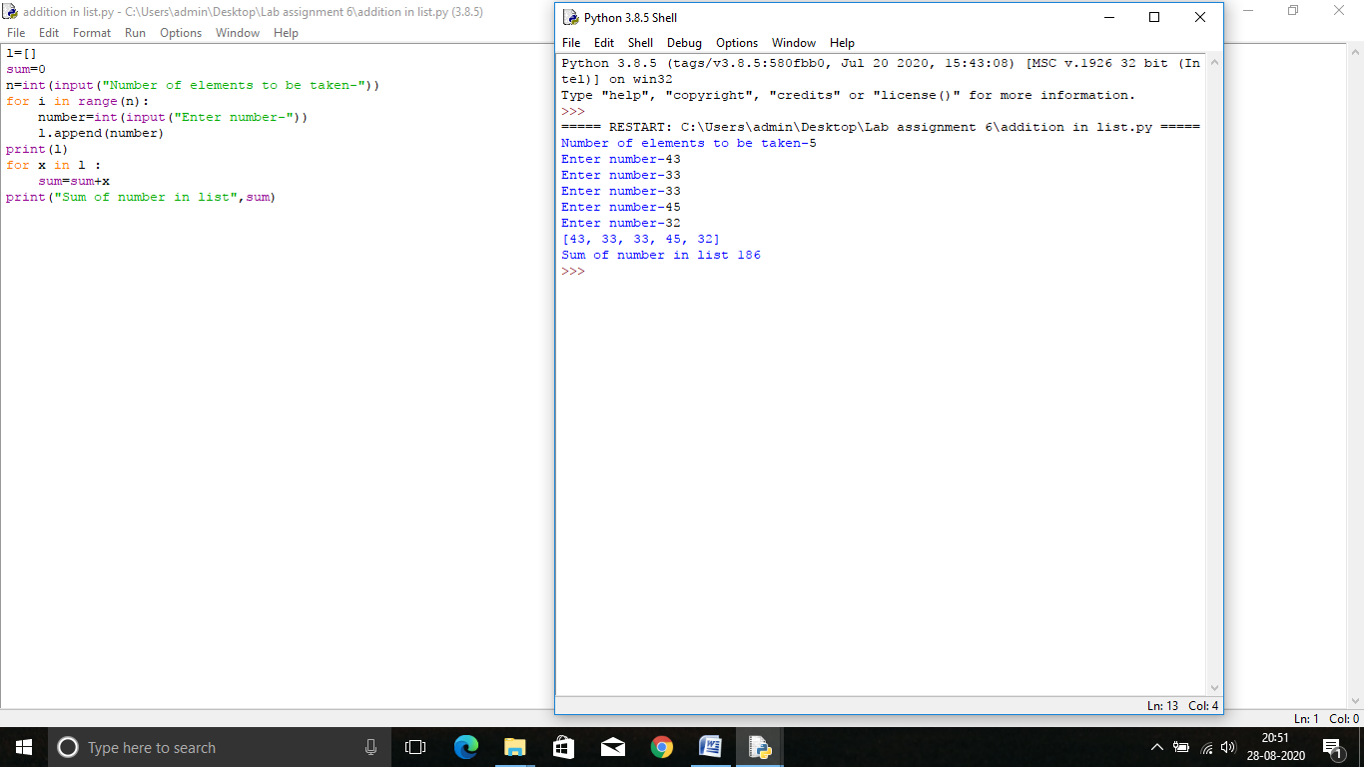

**Lab Assignment #7(TUPLES)**

1. write a program in Python to create two matrices A and B of three into three dimension store some integers into them find out the sum of the two metrics and stored the result in matrix C.DisplaymatrixA, metrics B and metrics C.

Note: solve the above metrics problem using tuple data type

1. write a program to create a matrix of 4 * 4 except some values from the user and store them into the matrix.Find out the sum of each row each column and bought the diagonals and display them on the screen .
2. Write a program to read email IDs of n number of students and store them in a tuple. Create two new tuples, one to store only the usernames from the email IDs and second to store domain names from the email ids. Print all three tuples at the end of the program. [Hint: You may use the function split()
3. Write a program to input names of n students and store them in a tuple. Also, input a name from the user and find if this student is present in the tuple or not. 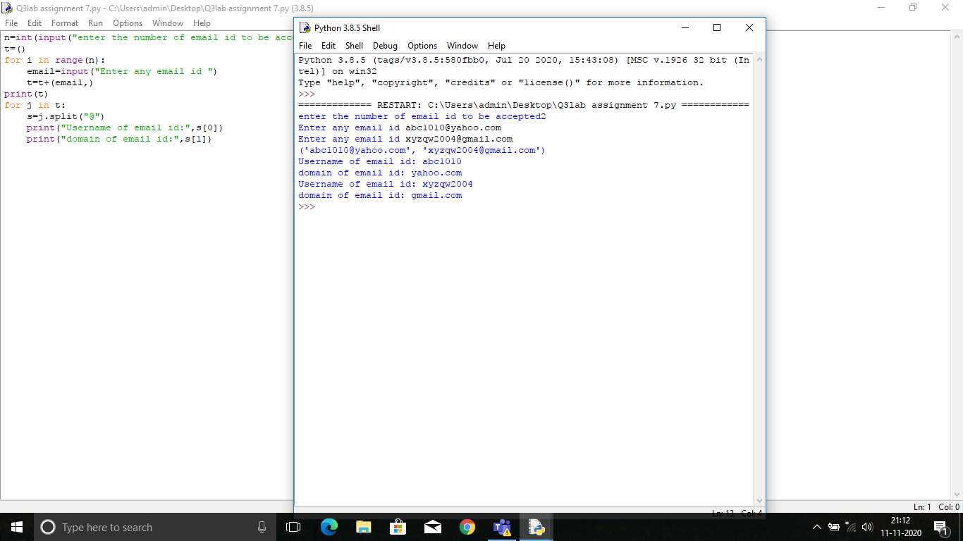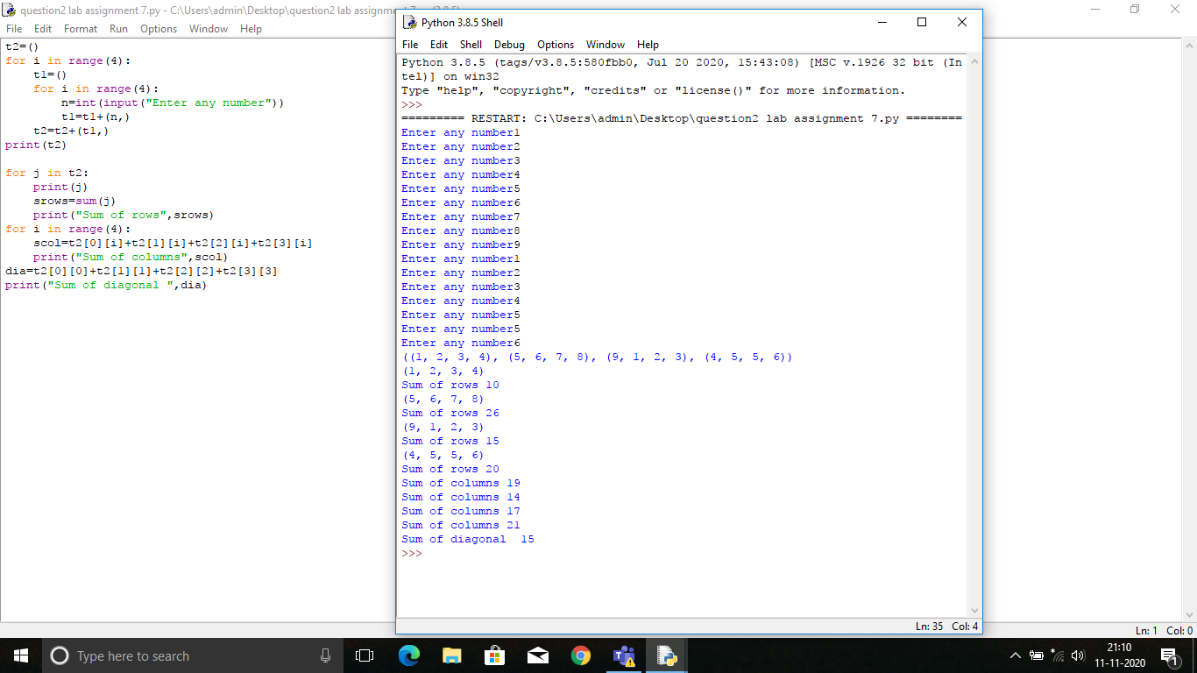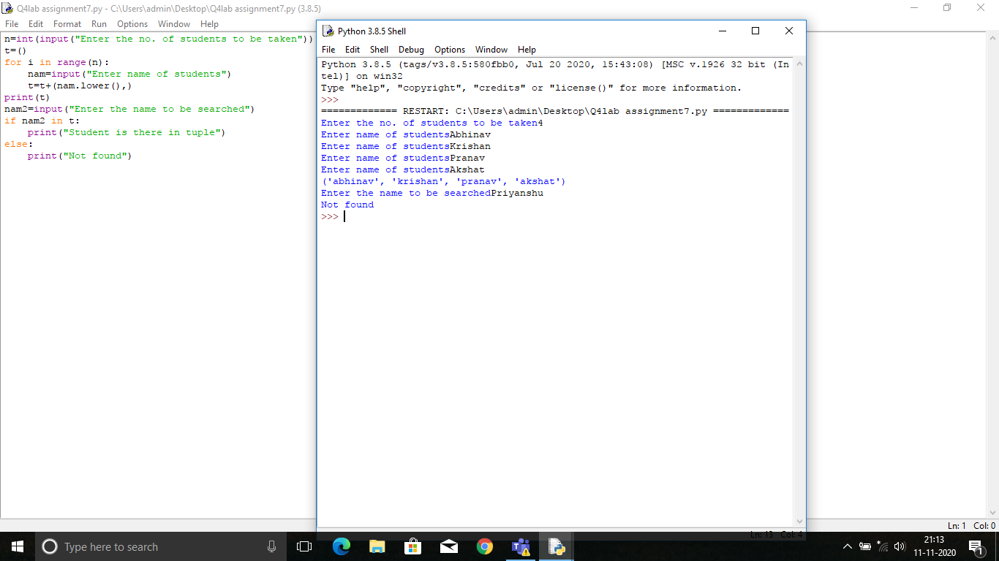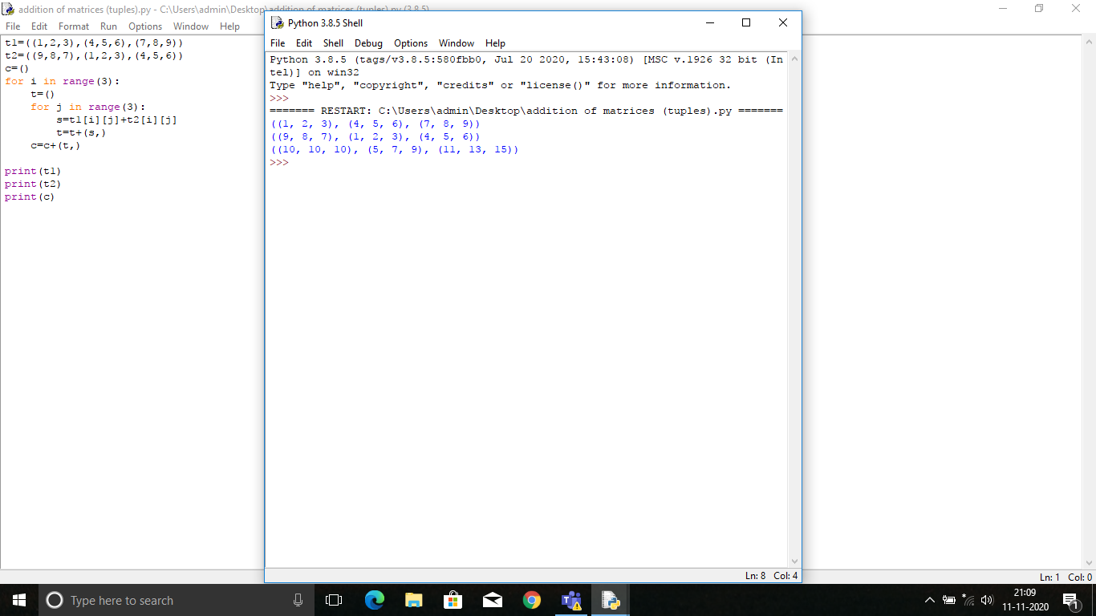

**LAB ASSIGNMENT 8**

**DICTIONARIES IN PYTHON**

1. **Write a python program to input ‘n’ names and phone numbers to store it in a dictionary and to input any name and to print the phone number of that particular name.**
2. **Write a program to input ‘n’ employee number and name and designation and salary calculate thebonus .**

**Bonus criteria**

**Salary Bonus**

**>=50000 10 % of the salary**

**>=30000 and < 50000 15 % of the salary**

**<30000 20 % of the salary**

**Give the following options in the program**

1. **Add a record**
2. **Update record**
3. **Delete a record**
4. **Display all records of all the employees in ascending order of their Employee number**
5. **Exit**
6. **Write a Python program to multiply all the items in a dictionary.**
7. **Write a program in python to find the frequency of all the characters in a string using dictionary data type**
8. **Akshara stored record of number of students she has trained in different languages in a of dictionary with name of the language as key and number of students trained as value. Now she wants to retrieve the name of language for which she has trained more than 100 students. Help her with the code to retrieve the information**

**Structure if dictionary is:**

**Language= {“java”:100, “python”:200, “C++”:500}**

**Note: there may be many more languages other that the three languages listed in the dict**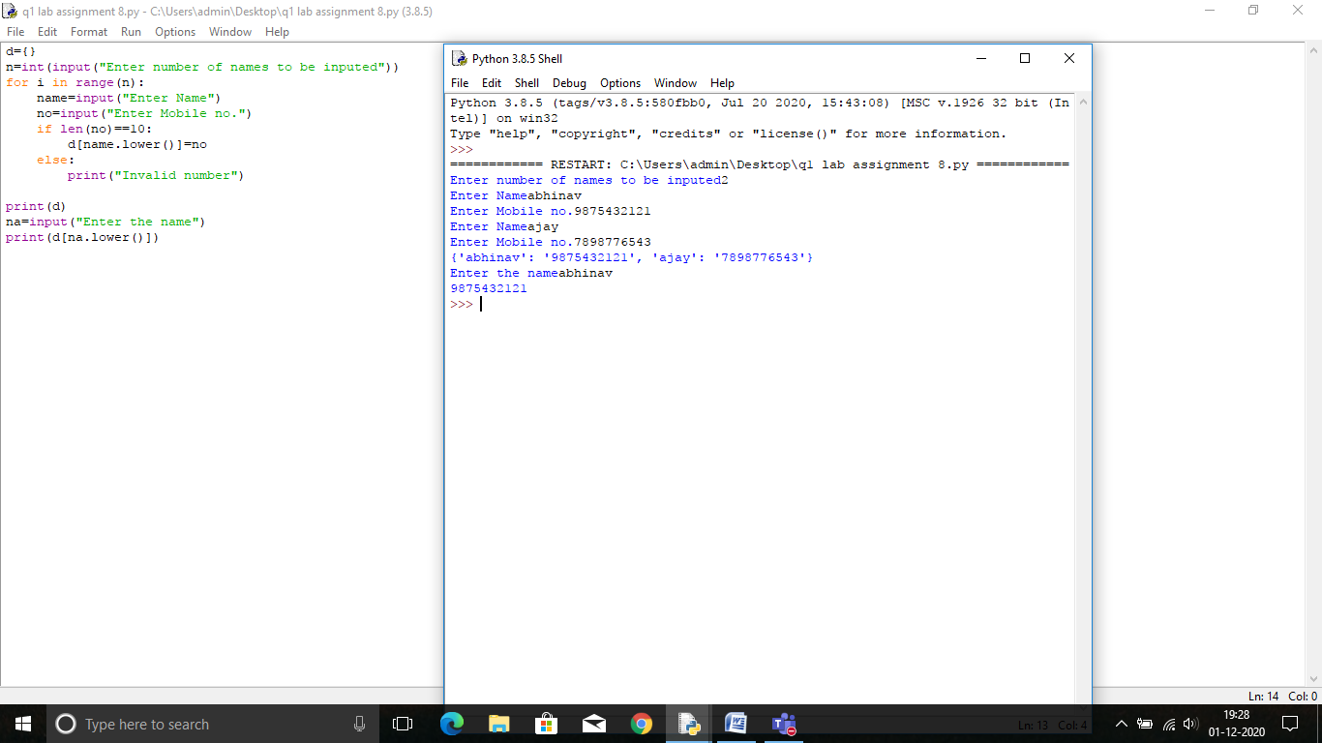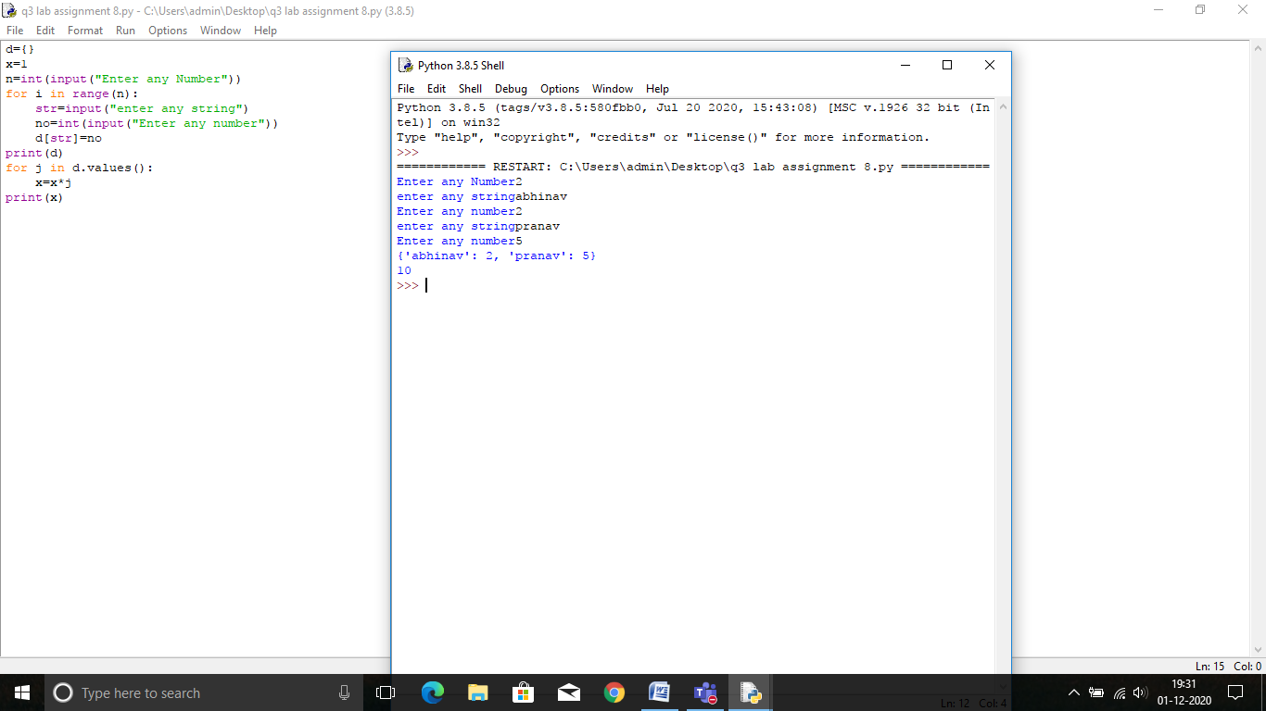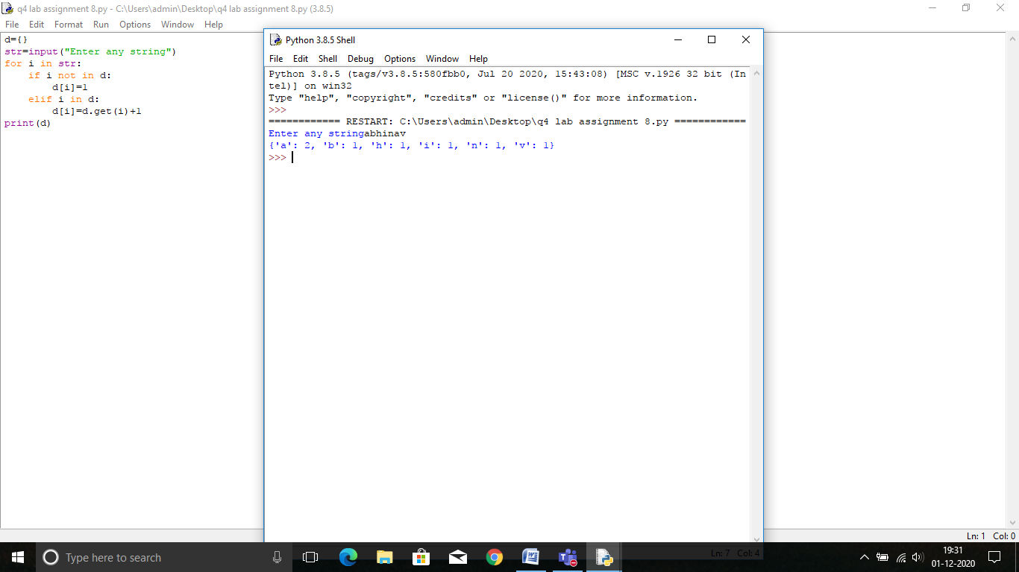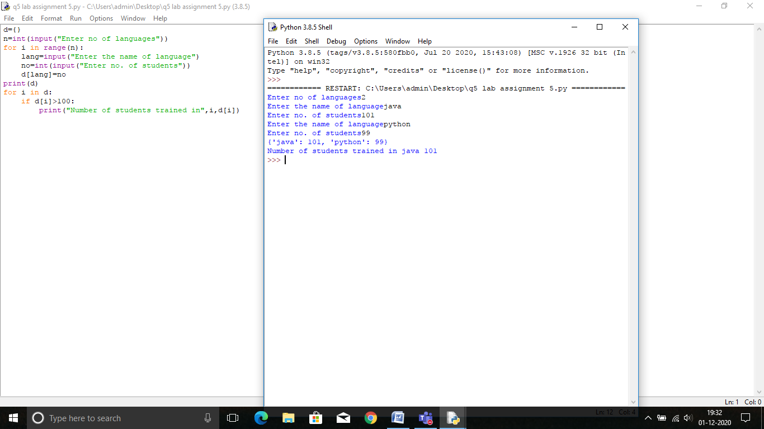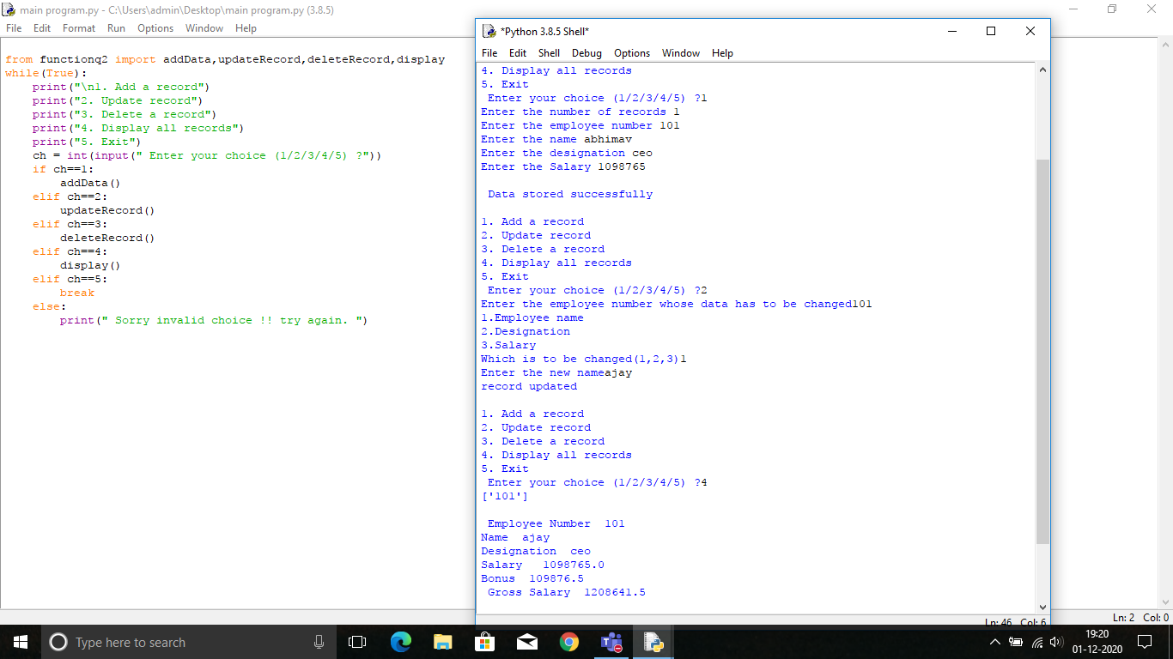

**Lab assignment 9**

Answer 1

def searchlinear(lst,element):

for i in range(len(lst)):

if lst[i]==element:

return i+1

return 'element not found'

x=[1,4,6,34,65,98,23]

print(searchlinear(x,23))

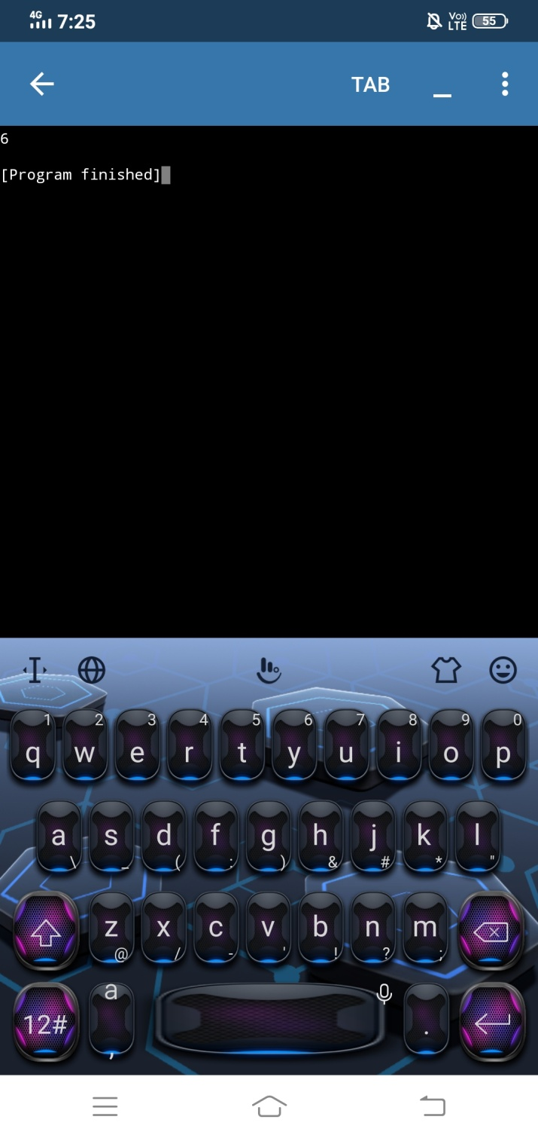

Answer 2: Binary search

def searchbinary(arr,x):

arr.sort()

l = 0

h = len(arr)-1

while l <= h:

m = (l + h) // 2

if x== arr[m]:

return 'Number found at',m+1

break

elif x > arr[m]:

l = m+ 1

else:

h = m- 1

if l > h:

return "number not found"

x=[43,34,21,23,12,56,65,33]

print(searchbinary(x,23))

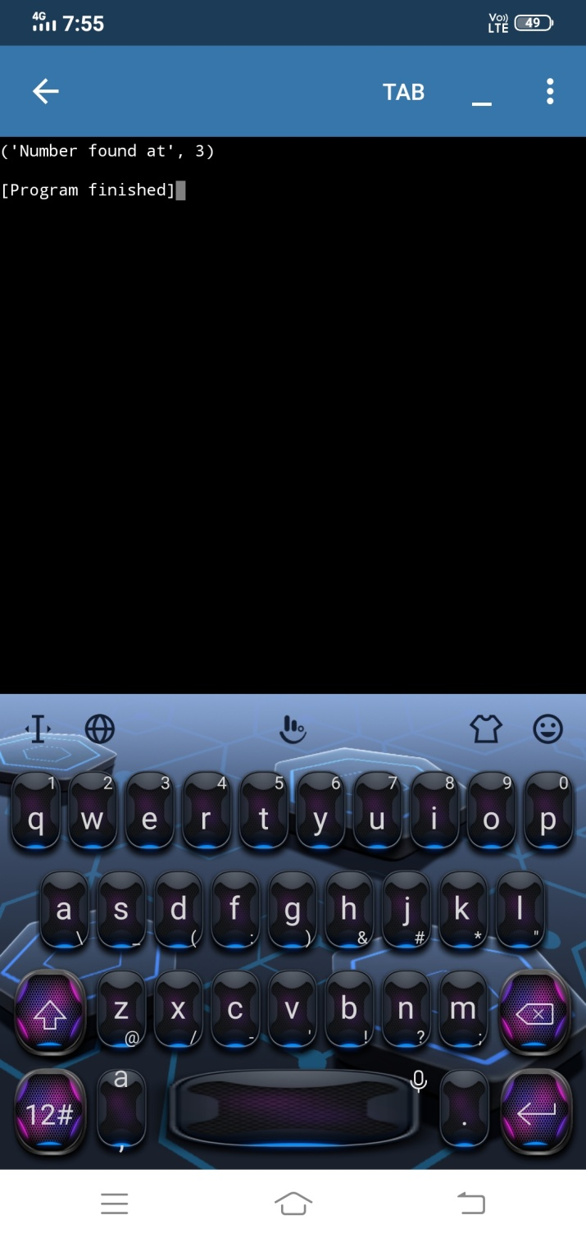

**Lab assignment 10**

Bubble sort

def bubblesort(l):

for i in range (len(l)):

for j in range(len(l)-1-i):

if l[j+1]<l[j]:

l[j],l[j+1]=l[j+1],l[j]

return l

x=[23,12,54,88,98,1,4,2,76,22]

bubblesort(x)

print(x)

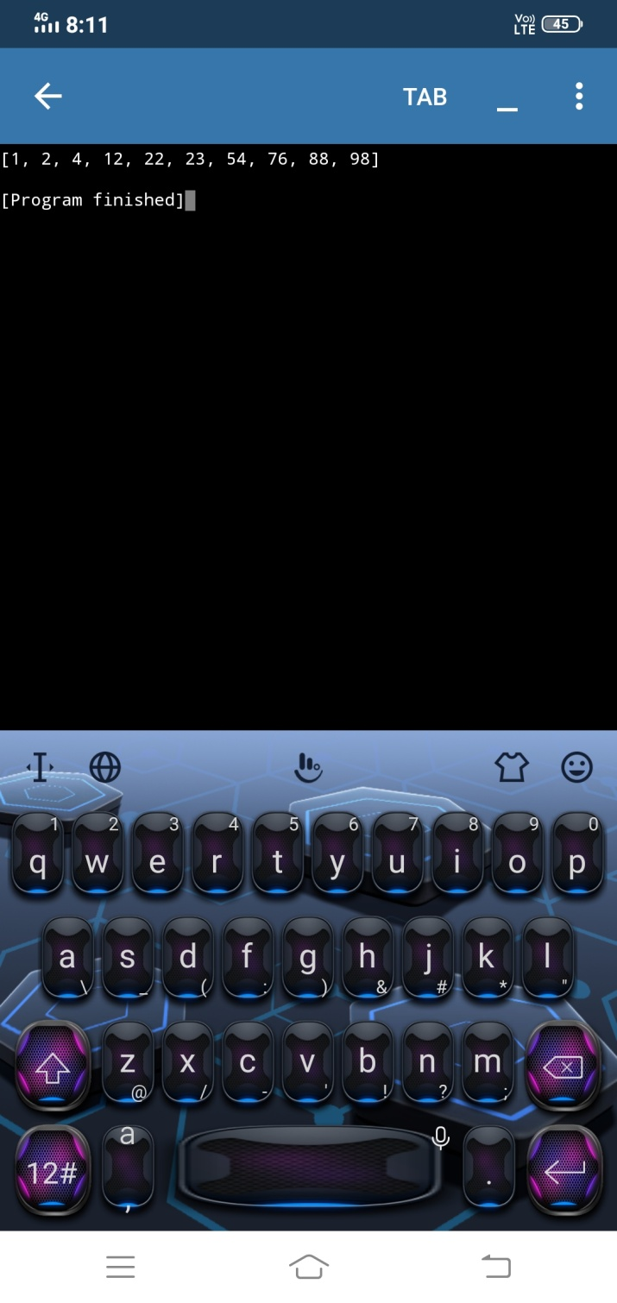

Answer 2: insertion sort

def insertionsort(arr):

for i in range(1, len(arr)):

key =arr[i]

j = i-1

while j >=0 and key < arr[j] :

arr[j+1] = arr[j]

j -= 1

arr[j+1] = key

x=[23,4,56,87,34,54,2,3,5,6,1]

insertionsort(x)

print(x)

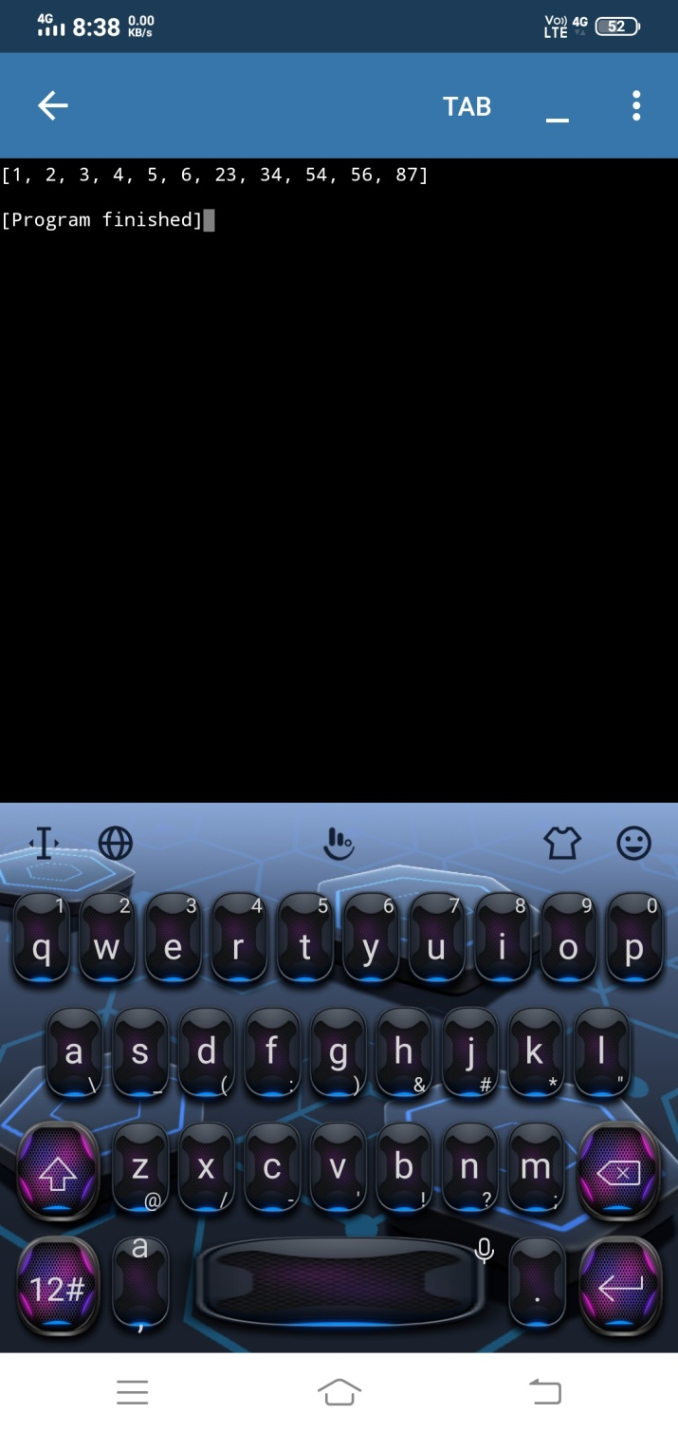

**CLASS 12 LAB ASSIGNMENT 1**

1. **Write a Python function to validate(nm, ph) return true if the name has all alphabets or spaces and phone number has 10 digits only, and returns false if any of the value is invalid**
2. **Write a Python function that accepts a string and calculate the number of upper case letters and lower case letters.   
   *Sample String*: 'The quick Brow Fox'  
   *Expected Output*:  
   No. of Upper case characters : 3  
   No. of Lower case Characters : 12**
3. **Write a Python function that takes a number as a parameter and check the number is prime or not**
4. **Write a Python function to check whether a number is perfect or not.**

**According to Wikipedia : In number theory, a perfect number is a positive integer that is equal to the sum of its proper positive divisors, that is, the sum of its positive divisors excluding the number itself (also known as its aliquot sum). Equivalently, a perfect number is a number that is half the sum of all of its positive divisors (including itself).  
*Example* : The first perfect number is 6, because 1, 2, and 3 are its proper positive divisors, and 1 + 2 + 3 = 6. Equivalently, the number 6 is equal to half the sum of all its positive divisors: ( 1 + 2 + 3 + 6 ) / 2 = 6. The next perfect number is 28 = 1 + 2 + 4 + 7 + 14. This is followed by the perfect numbers 496 and 8128.**

1. **Write a Python function modify(lst) that takes a list of numbers as a parameter and changes all the multiples of 5 to 0 and other numbers to 1**

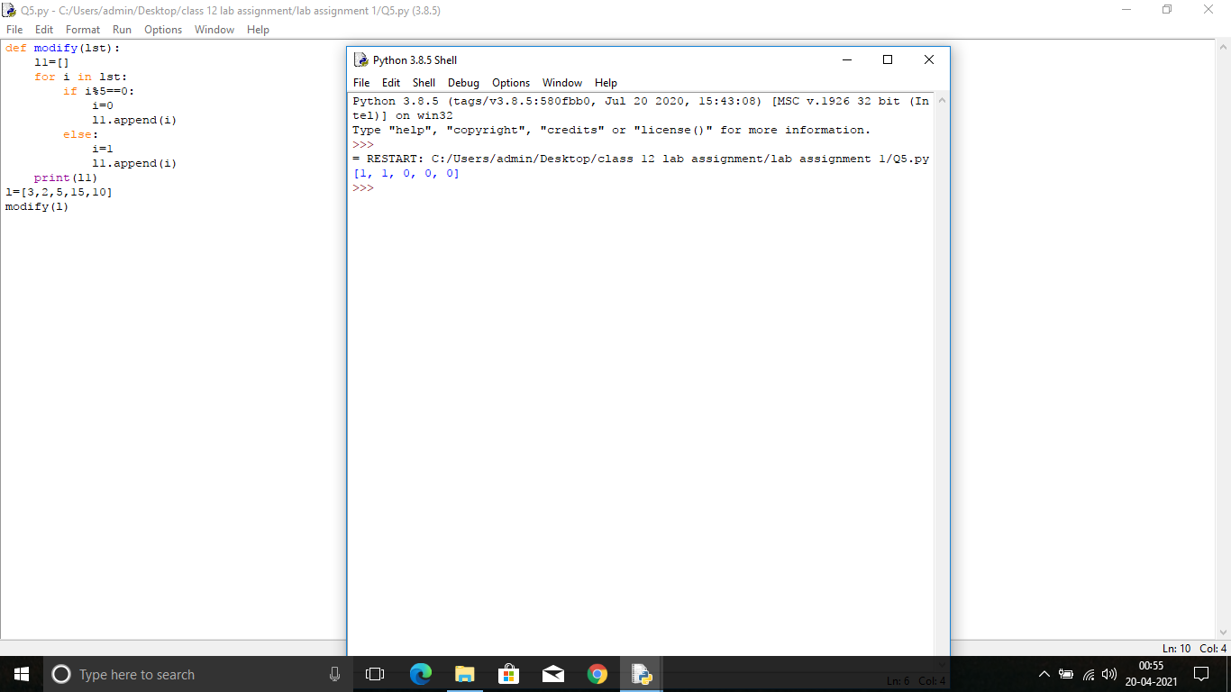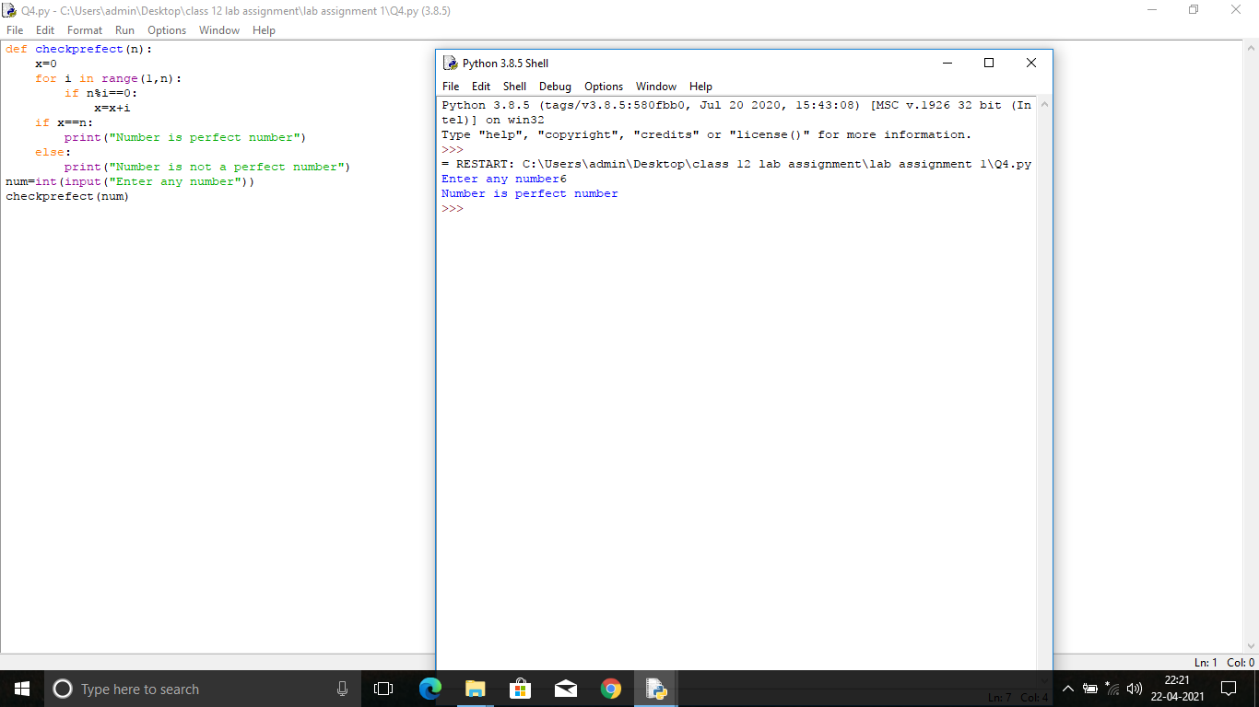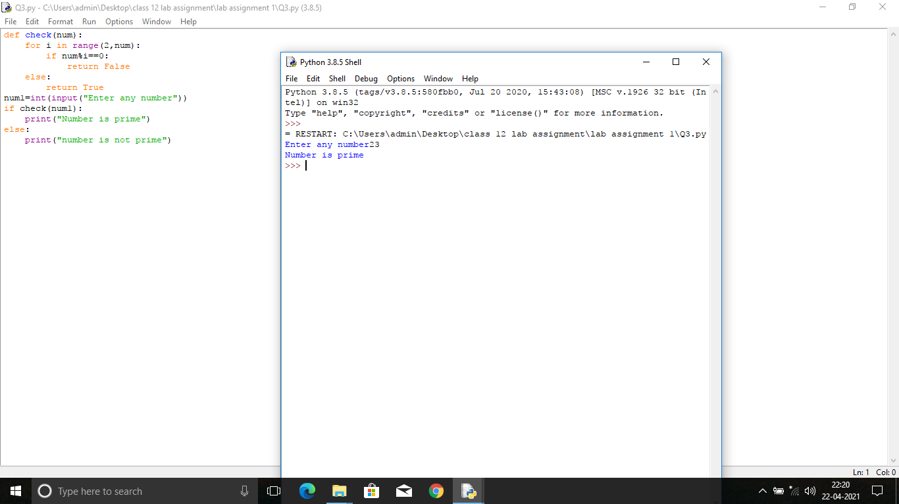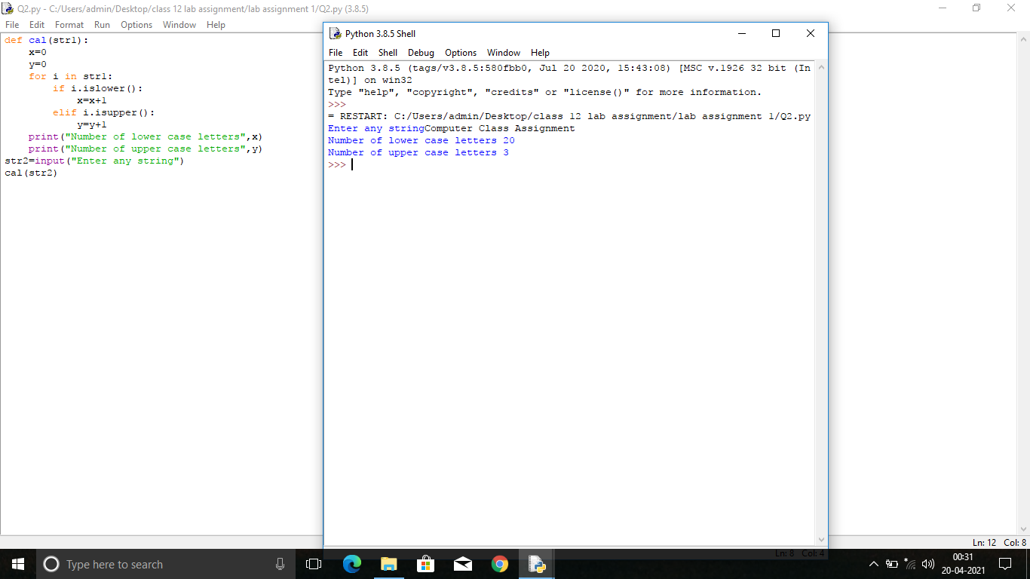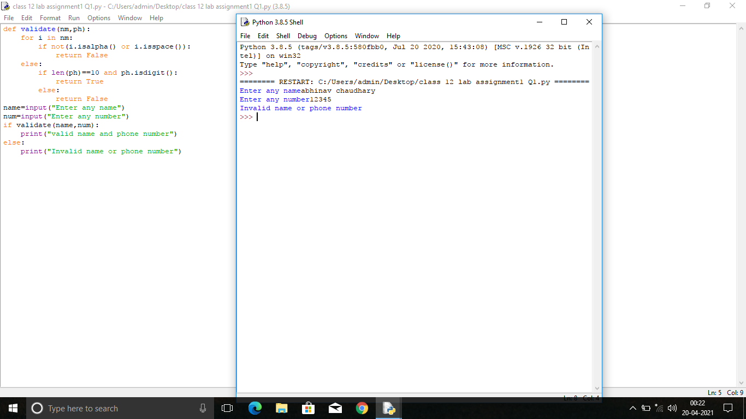

LAB ASSIGNMENT 2

RECURSION

1.Write a recursive function to find the factorial of a number

def recur_factorial(n):

if n == 1:

return n

else:

return n*recur_factorial(n-1)

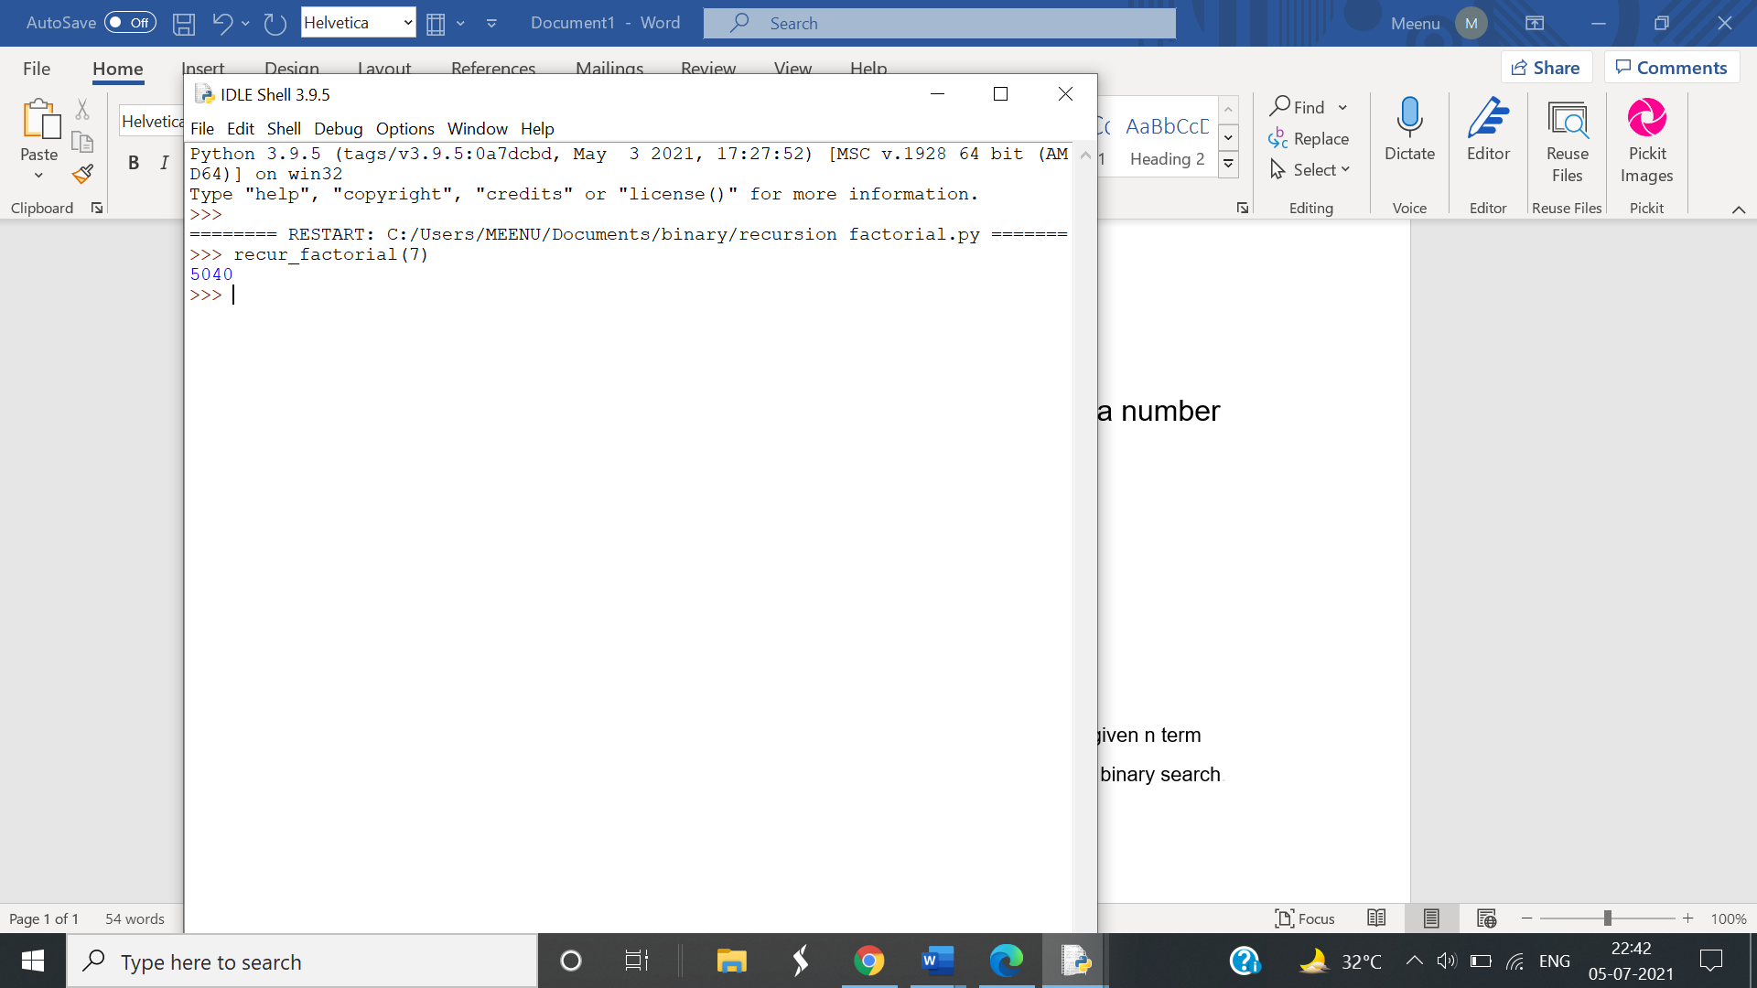

2. Write a recursive function to generate Fibonacci series upto a given n term.

def fibonacci(num):

if num <= 1:

return num

else:

return(fibonacci(num-1)+fibonacci(num-2))

n=int(input("Enter how many terms:"))

for i in range(n):

print(fibonacci(i))

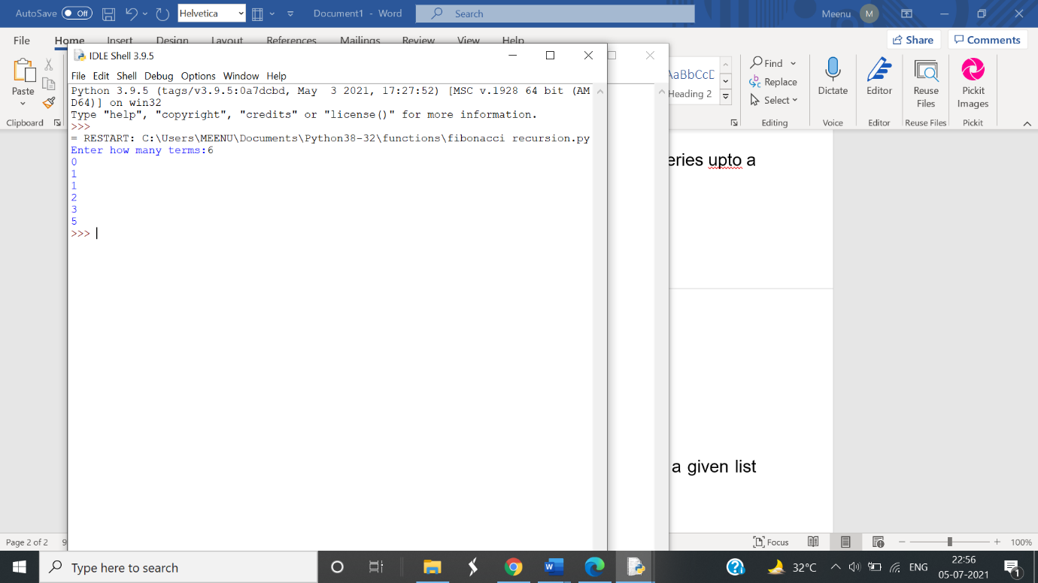

3.Write a recursive function to search a number in a given list using binary search..

def binary_search_recursive(arr, elem, start=0, end=None):

if end is None:

end = len(arr) - 1

if start > end:

return False

mid = (start + end) // 2

if elem == arr[mid]:

return mid

if elem < arr[mid]:

return binary_search_recursive(arr, elem, start, mid-1)

return binary_search_recursive(arr, elem, mid+1, end)

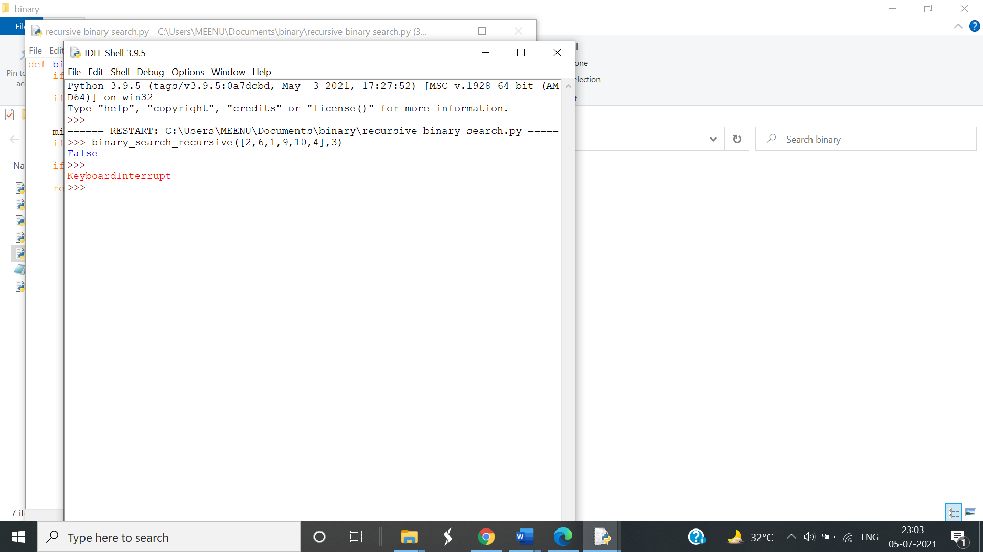

***ASSIGNMENT 3 (TEXT FILES***)

1. Write a program to read data from a file. All lower case letters are stored inside the file “LOWER.txt”, all upper case characters get stored inside the file “UPPER.txt” and all other characters stored inside the file “OTHERS.txt”.

2. Write a function in python to count the number of lines in a text file ‘STORY.txt’ which is starting with an alphabet ‘A’ .

3. Write a function in python to count the number of vowels in the file ‘STORY.txt’.

4. Write a function in Python that counts the number of “Me” or “My” (in smaller case also) words present in a text file “STORY.TXT”. If the “STORY.TXT” contents are as follows:

My first book was Me and My Family. It gave me chance to be Known to the world.

The output of the function should be: Count of Me/My in file: 4

5. Write a function AMCount() in Python, which should read each character of a text file STORY.TXT, should count and display the occurence of alphabets ‘A’ and ‘M’ (including small cases ‘a’ and ‘m ‘too). Example: If the file content is as follows:

Updated information As simplified by official websites.

The AMCount() function should display the output as: A or a = 4, M or m =2

6. Write a method/function DISPLAYWORDS() in python to read lines from a text file STORY.TXT, and display those words, which are less than 4 characters.

7. Write a function RevText() to read a text file “ Story.txt “ and Print only word starting with ‘I’ in reverse order . Example: If value in text file is: INDIA IS MY COUNTRY Output will be: AIDNI SI MY COUNTRY.

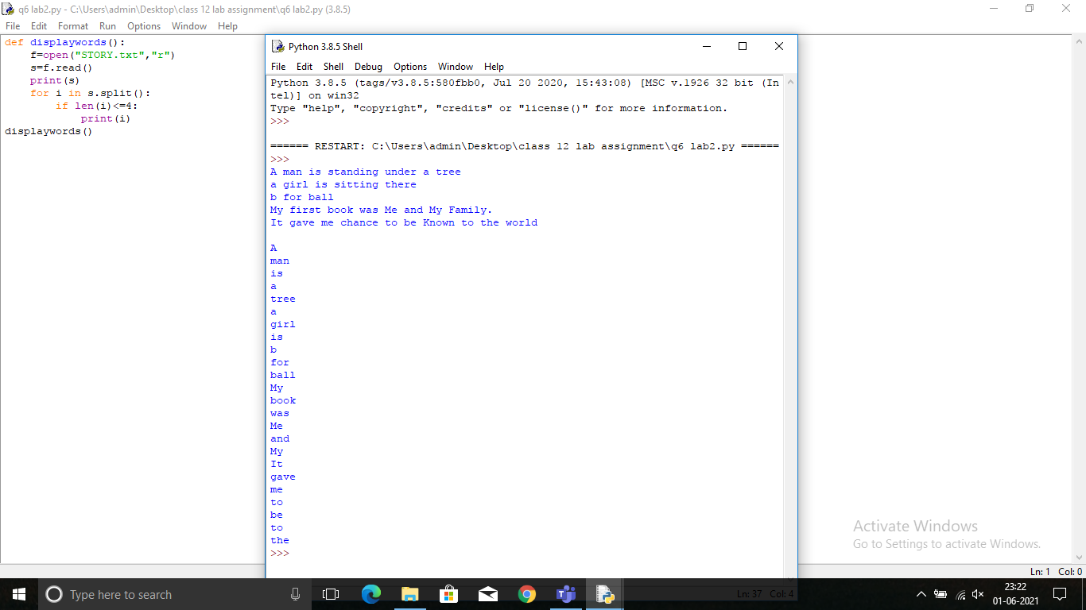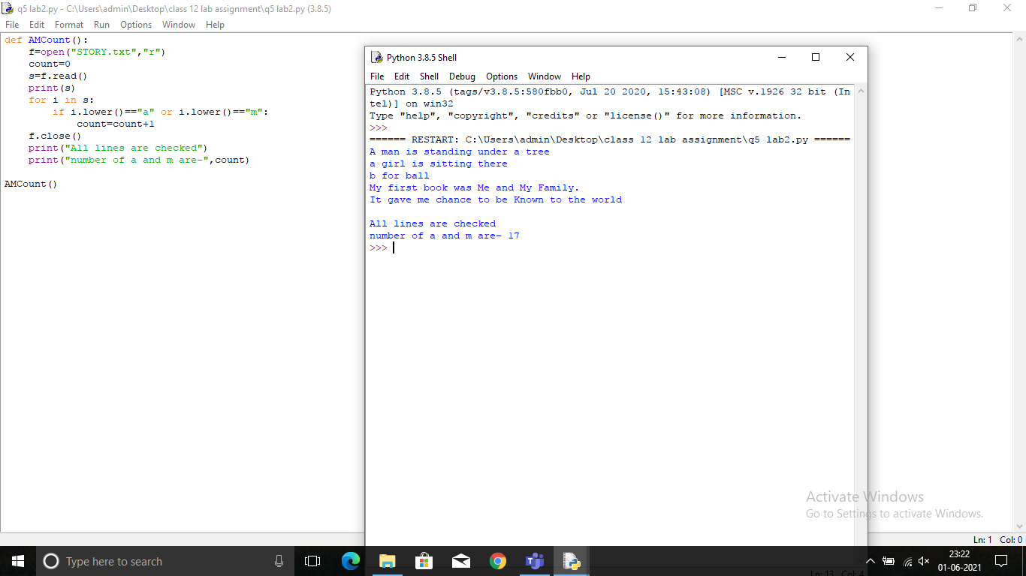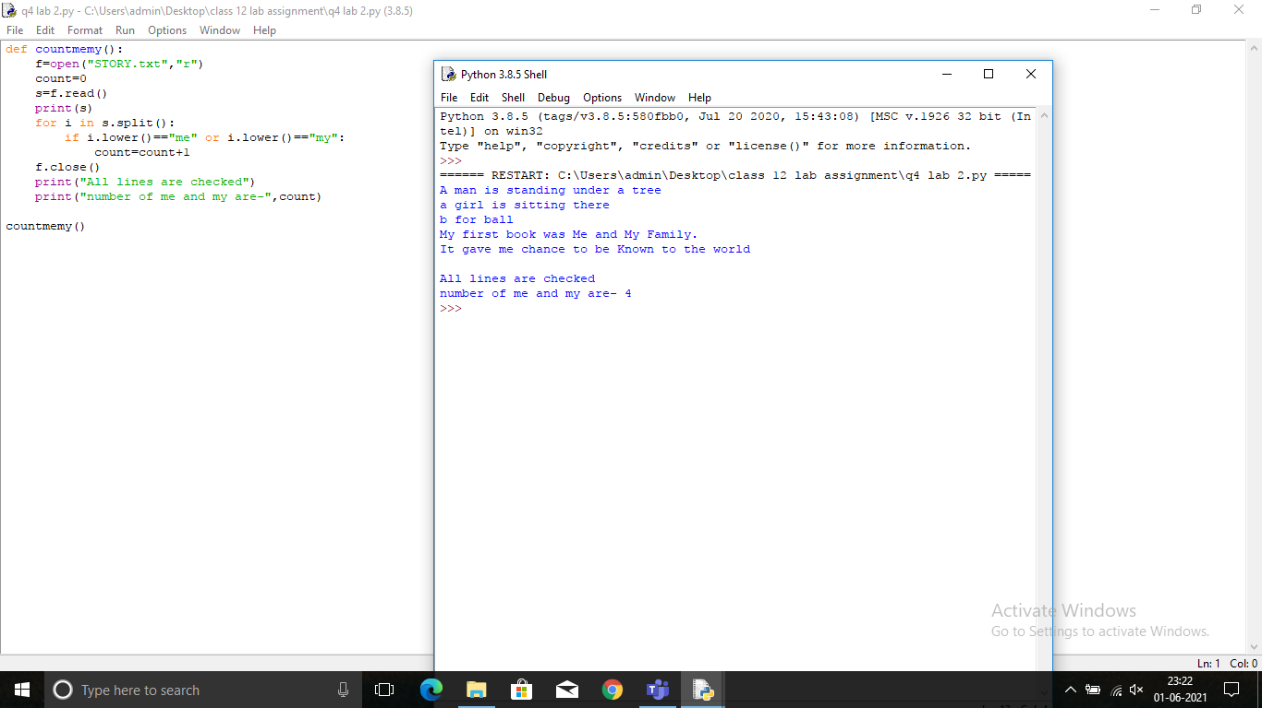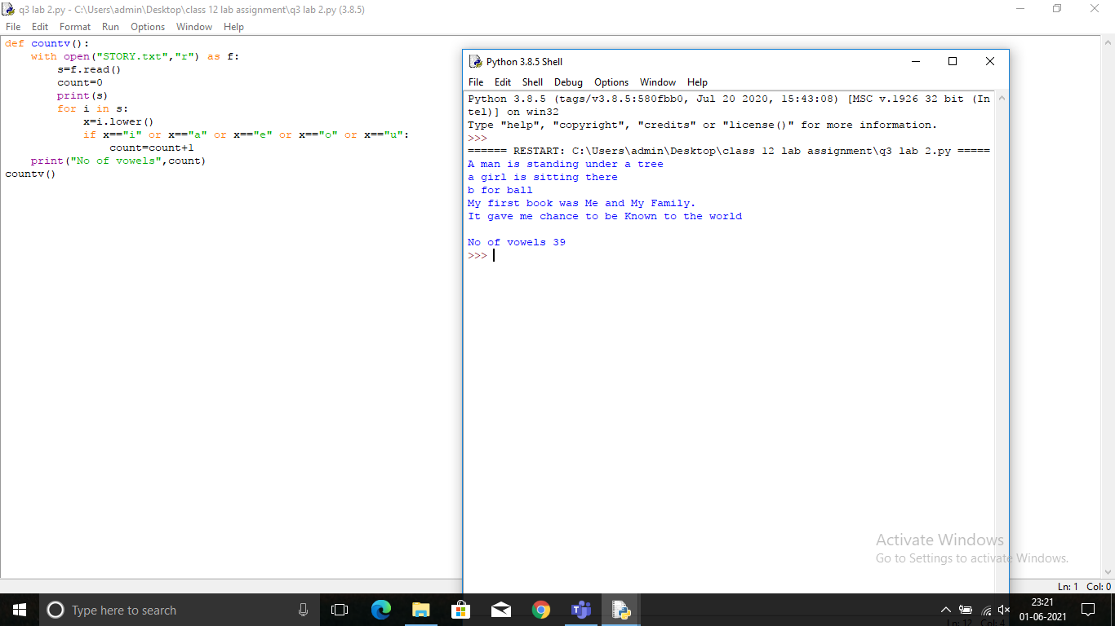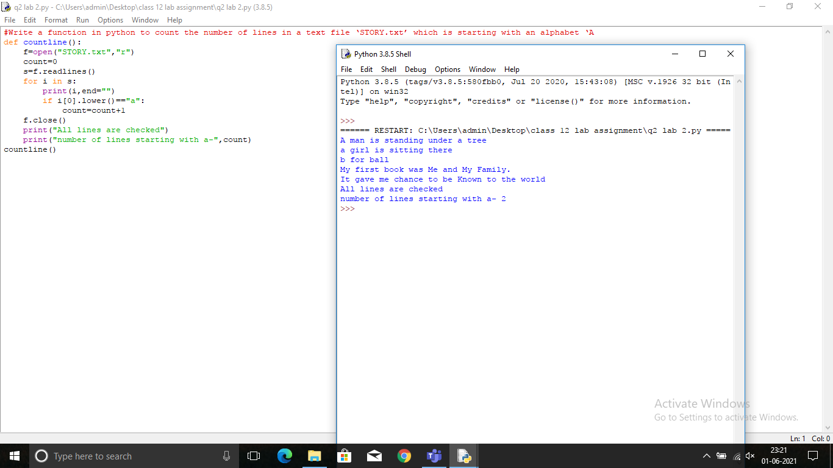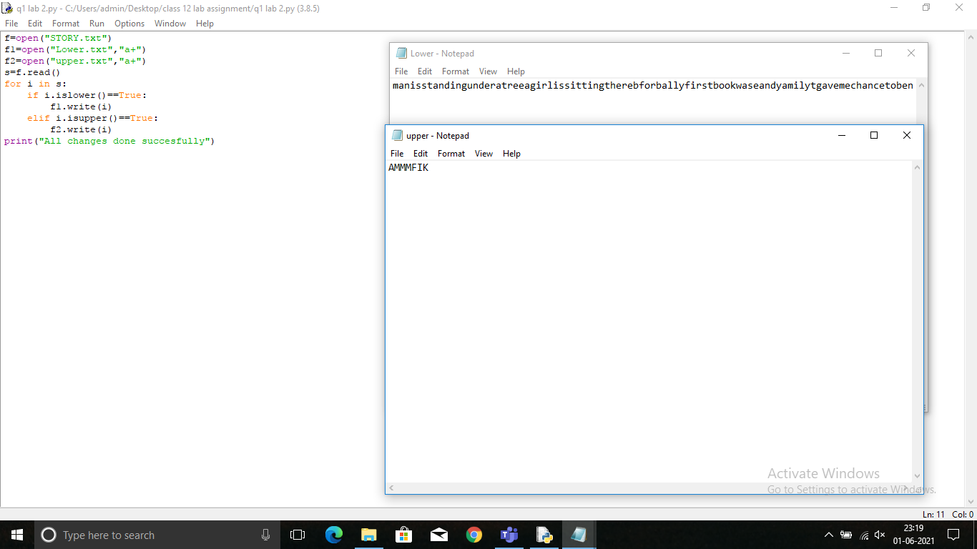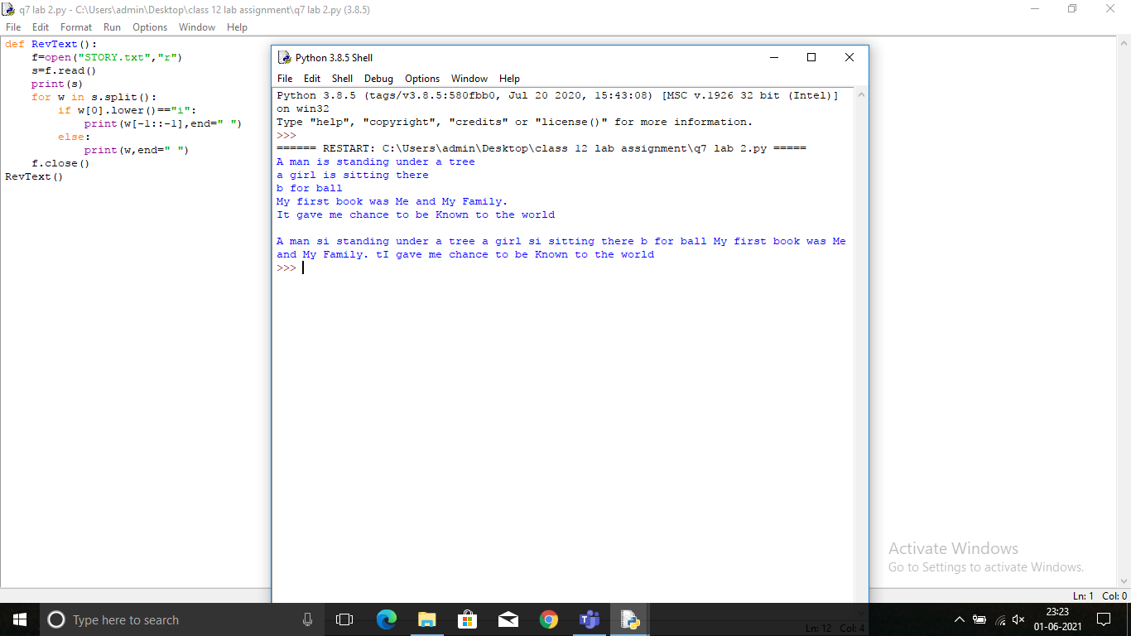

LAB ASSIGNMENT 4 (TEXT FILES)

1.Write a program to read data from a file. All lower case letters are stored inside the file “LOWER.txt”, all upper case characters get stored inside the file “UPPER.txt” and all other characters stored inside the file “OTHERS.txt”.

with open("LOWER.txt") as f:

s=f.read()

print(s)

with open("UPPER.txt") as f2:

s2=f2.read()

print(s2)

with open("OTHERS.txt") as f3:

s3=f3.read()

print(s3)

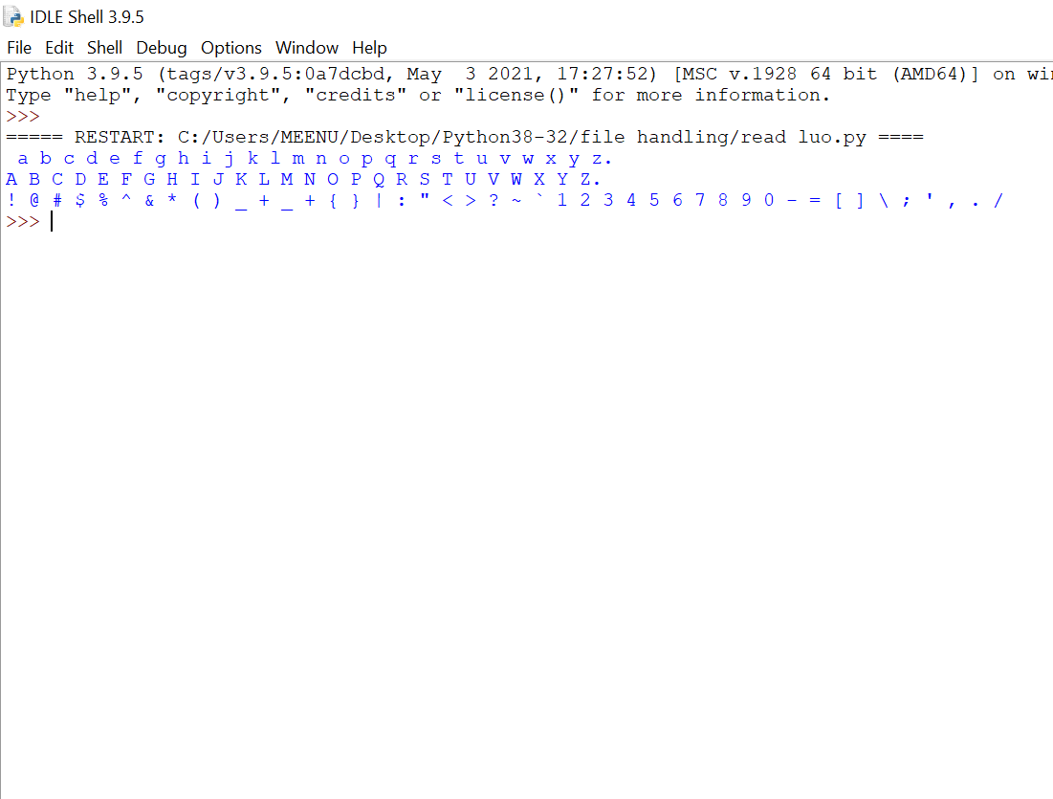

2. Write a function in python to count the number of lines in a text file ‘STORY.txt’ which is starting with an alphabet ‘A’ .

with open("STORY.txt") as f:

s=f.readline()

while s!="":

w=s.split()

if(w[0]=="A"):

print(s)

s=f.readline()

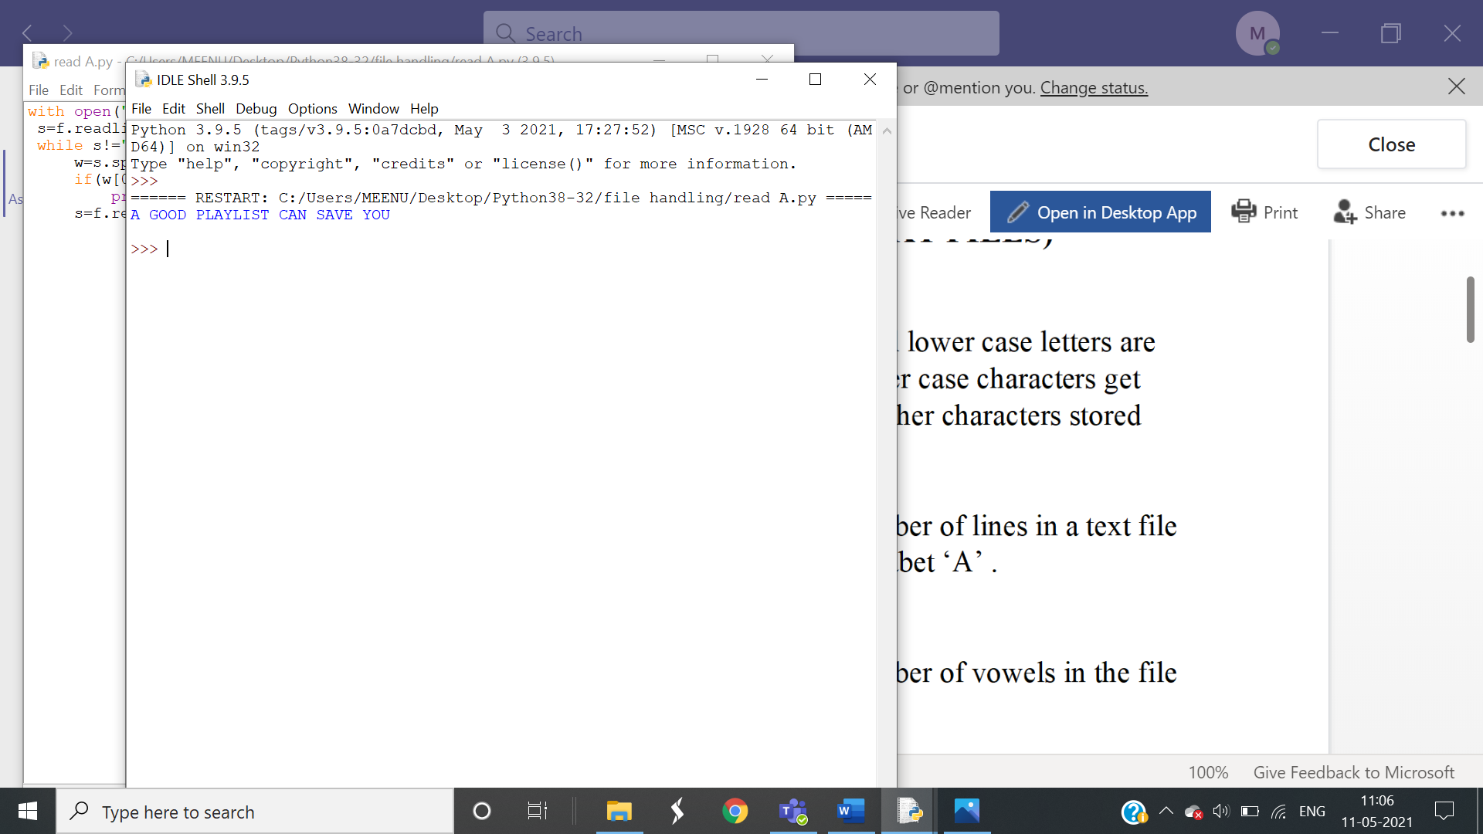

3. Write a function in python to count the number of vowels in the file ‘STORY.txt’

# FUNCTION FOR COUNTING VOWELS IN A LIST (LIST BECAUSE THE FUNCTION FILE.READLINES() RETURNS OUTPUT IN LIST FORMAT)

def v(lst):

count=0

count1=0

count2=0

count3=0

count4=0

for i in range(len(lst)):

for j in range(len(lst[i])):

if lst[i][j]=="a":

count=count+1

elif lst[i][j] =="e":

count1=count1+1

elif lst[i][j]=="i":

count2=count2+1

elif lst[i][j]=="o":

count3=count3+1

elif lst[i][j]=="u":

count4=count4+1

return count,count1,count2,count3,count4

# MAIN PROGRAM

import vowels

with open("STORY.txt") as f:

s=f.readlines()

z=vowels.v(s)

print(" a has occured",z[0],"times")

print(" e has occured",z[1],"times")

print(" i has occured",z[2],"times")

print(" o has occured",z[3],"times")

print(" u has occured",z[4],"times")

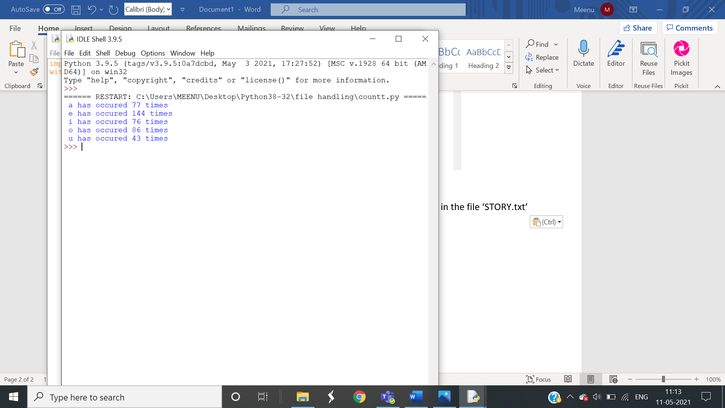

4. Write a function in Python that counts the number of “Me” or “My” (in smaller case also) words present in a text file “STORY.TXT”. If the “STORY.TXT” contents are as follows:

with open("demo2.txt") as f:

q="meMemyMy"

count=0

s=f.readline()

while s!="":

w=s.split()

for i in range(len(w)):

if(w[i] in q):

count=count+1

s=f.readline()

print("count of Me/My= ",count)

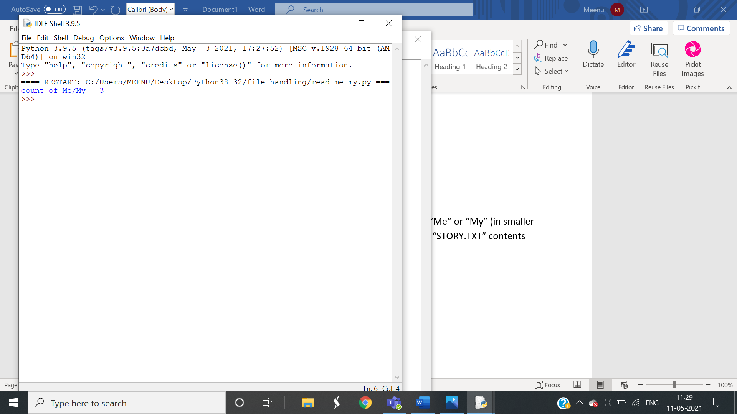

5.Write a function AMCount() in Python, which should read each character of a text file STORY.TXT, should count and display the occurence of alphabets ‘A’ and ‘M’ (including small cases ‘a’ and ‘m ‘too). Example: If the file content is as follows:

Updated information As simplified by official websites.

The AMCount() function should display the output as: A or a = 4, M or m =2

def AMCount():

with open("isis.txt") as f:

A=0

M=0

s=f.readline()

while s!="":

w=s.split()

for i in range(len(w)):

for j in w[i]:

if (j=="A" or j=="a") :

A=A+1

elif(j=="M" or j=="m"):

M=M+1

s=f.readline()

print("A or a: ",A)

print("M or m: ",M)

AMCount()

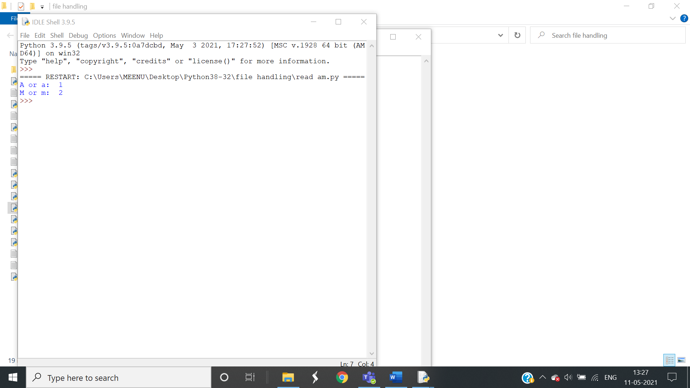

6. Write a method/function DISPLAYWORDS() in python to read lines from a text file STORY.TXT, and display those words, which are less than 4 characters

def DISPLAYWORDS():

c=0

file=open("STORY.txt",'r')

line = file.read()

while line!="":

word = line.split()

for w in word:

if len(w)<4:

print(w,end=" ")

line=file.read()

file.close()

DISPLAYWORDS()

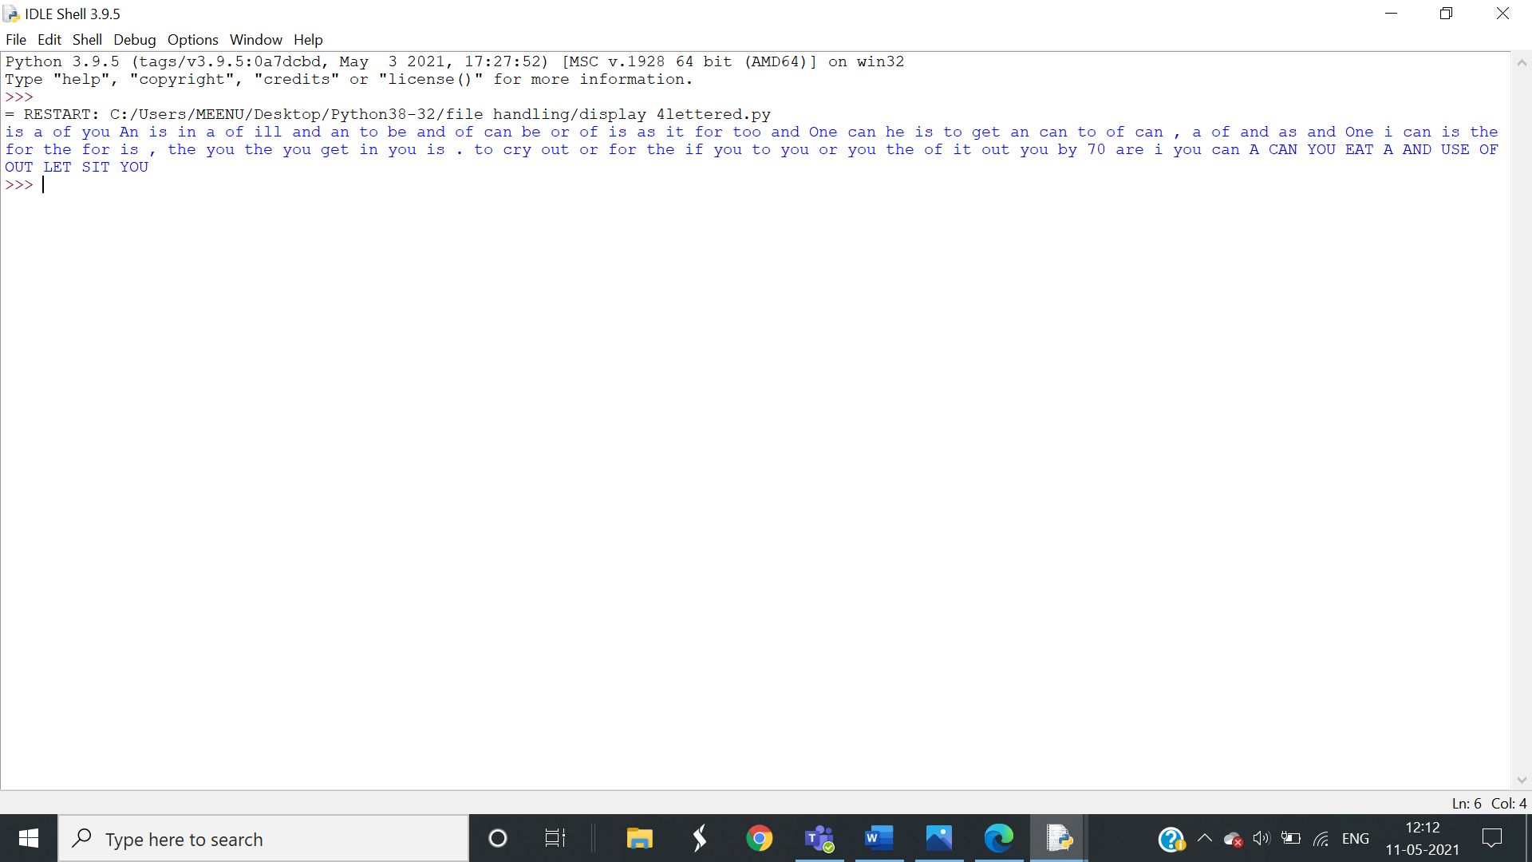

7. Write a function RevText() to read a text file “ Story.txt “ and Print only word starting with ‘I’ in reverse order . Example: If value in text file is: INDIA IS MY COUNTRY Output will be: AIDNI SI MY COUNTRY.

def RevText():

with open("isis.txt") as f:

s=f.readline()

d=""

w=s.split()

for i in range(len(w)):

if(w[i][0]=="I" or w[i][0]=="i"):

d=d+" "+w[i][::-1]

else:

d=d+" "+w[i]

print(d)

RevText()

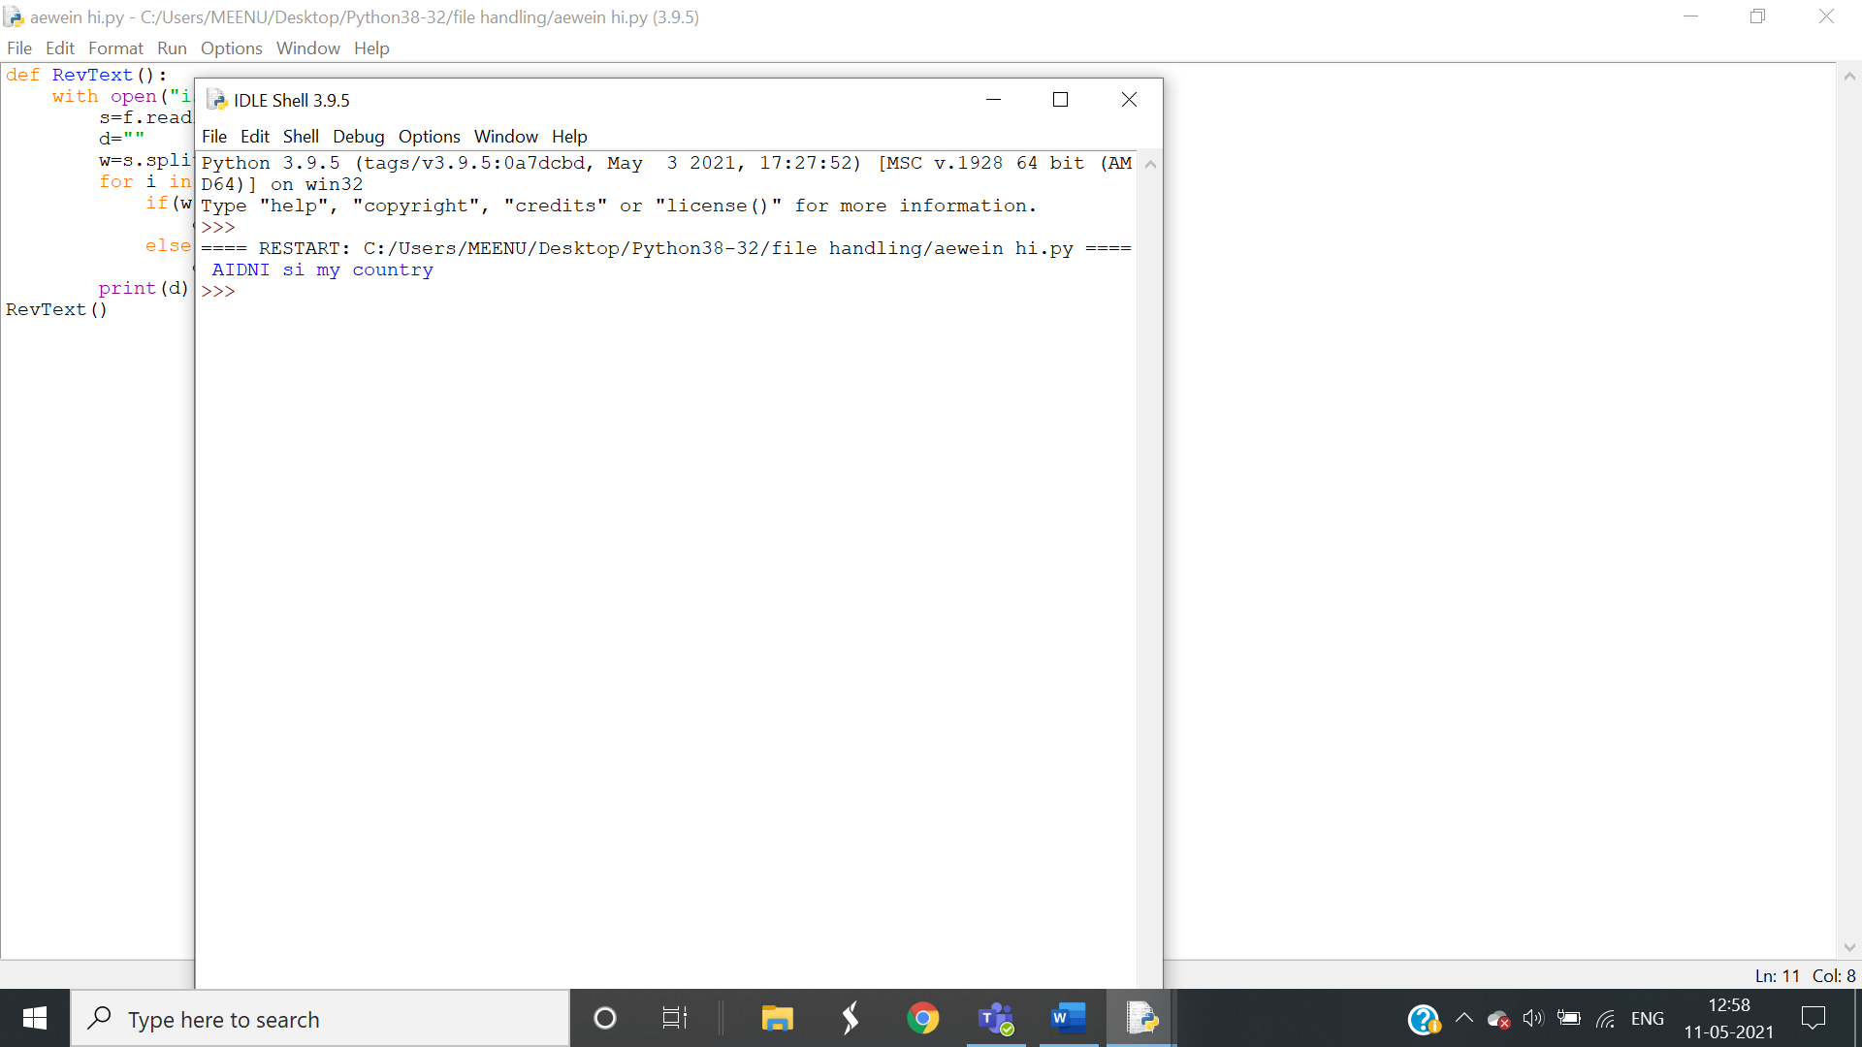

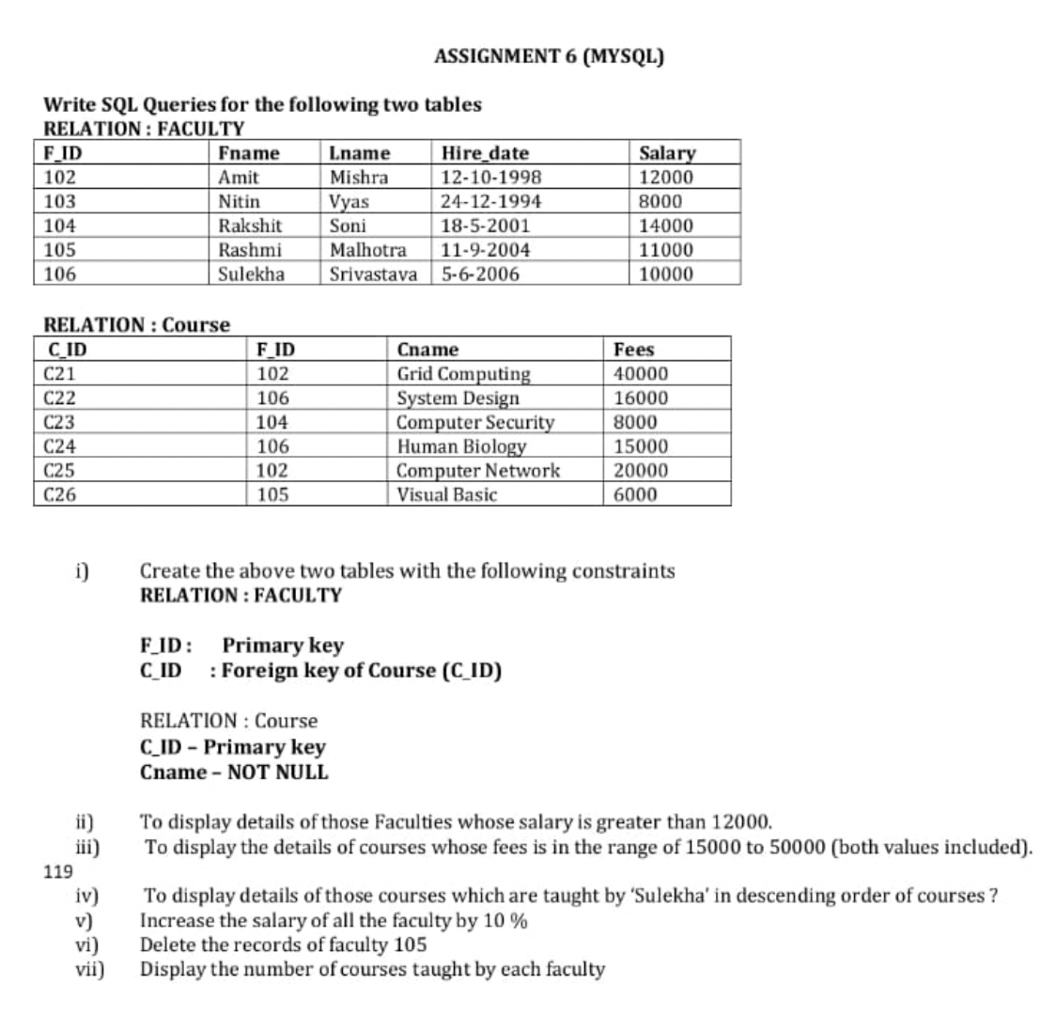 *i).*  **

ii). 

iii). 

iv). 

v). 

vi). 

vii). 

***Lab assignment 7***

Q Write menu driven program to demonstrate stack with push(),pop(),and display() for the following list structure.

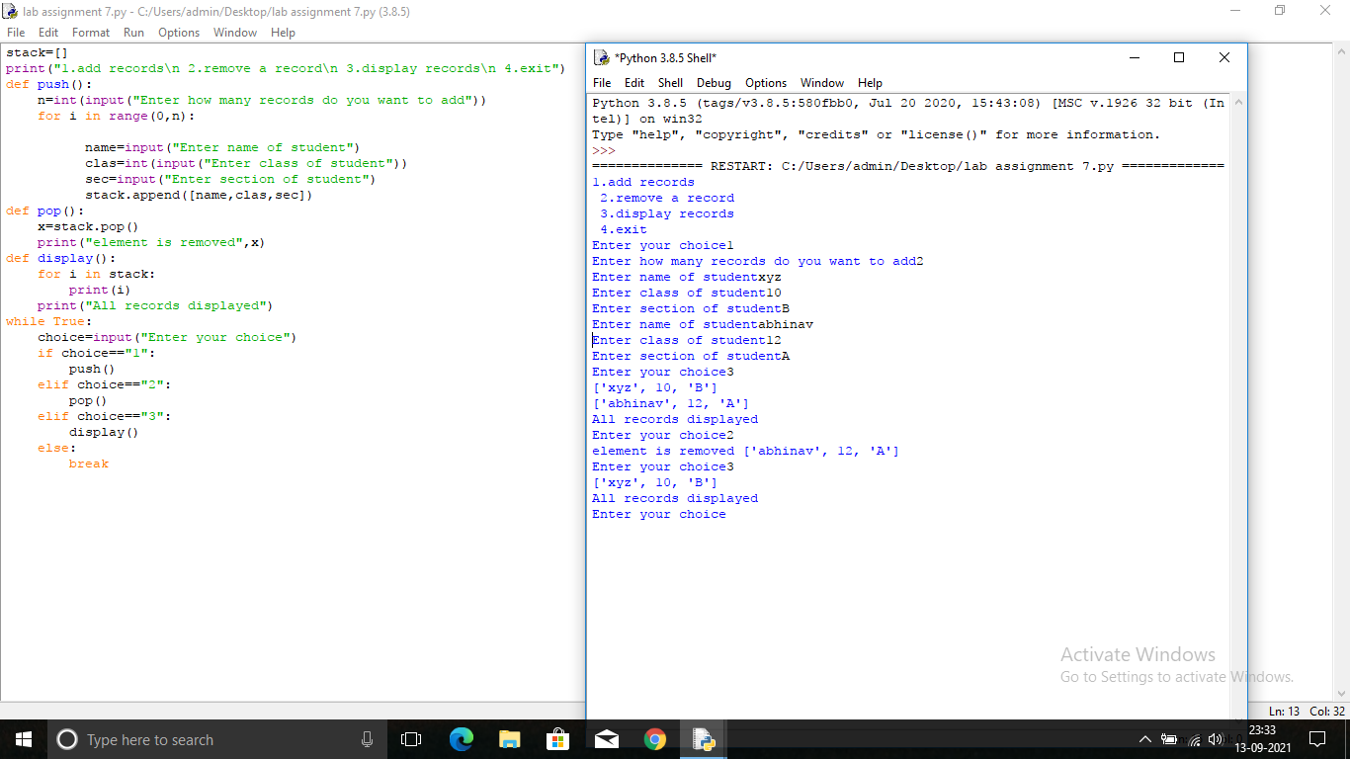

***Lab assignment 8***

Q.Write menu driven program to demonstrate queue with insert(),remove(), and display() for the following list structure.

